

**MAKERERE UNIVERSITY**

**COLLEGE OF ENGINEERING DESIGN ART AND TECHNOLOGY**

**SCHOOL OF ENGINEERING**

**DEPARTMENT OF ELECTRICAL AND COMPUTER ENGINEERING**

**THIRD YEAR FIELD ATTACHMENT REPORT AT**

**NETLABS!UG**



**SAMUEL VINALD OKIROR**

**REG NO. 20/U/6640/PS**

**STUDENT NO. 2000706640**

# DECLARATION

I, **SAMUEL VINALD OKIROR** hereby declare that I carried out the work presented in this report at netLabs!UG and to the best of my knowledge, no part of this report has been submitted here or elsewhere in a previous application for award of a degree.

Signature:

…………………………………………………………….

Date:

…………………………………………………………….

# APPROVAL BY THE SUPERVISORS

This is to certify that this report was compiled by SAMUEL VINALD OKIROR from his internship and has been submitted for examination with the approval of the supervisors.

**AGENCY SUPERVISOR**

**Mr. Frank Ssemakula**

**Graduate Research**

**netLabs!UG**

Signature: ………………………….………….…

Stamp & Date: …………….……………………..

**ACADEMICS SUPERVISOR**

**Dr. Kizito Ronald**

**Makerere University**

Signature: …………………….......……………..

Date: ………………………………………….…

# ACKNOWLEDGEMENT

In the name of God Almighty, my creator, who is the most merciful and most graceful and for being my strong pillar, my source of wisdom, knowledge and understanding. Special appreciation goes to Mrs. Okiror Dorothy, my mother for supporting me physically, financially and emotion throughout my industrial training period.

The internee feels greatly indebted to netLabs!UG staff, Dr. Edwin Mugume, Mr Frank Ssemakula, Ms Berna Namulyowa, Mr. Okello Wayne, Mr Abdunoor Kalibala, Ms Namulondo Gorret and Mr. Simon for the Technical and administrative assistance rendered during the stay at netLabs!UG and fellow internees Imran, Viola, Daphine, Patience, Ivan, Bruno and Nickson; with whom hours were spent with daily, accomplishing various tasks and making innovations together.

Finally, the internee would like to thank my Academic Supervisor, Dr. Kizito Ronald for the professional guidance and direction rendered to me to achieve this success.

# ABSTRACT

This report contains the details of the modules covered during internship period which spanned 8 weeks which (from 26th June to 18th August 2023) done at netLabs!UG.

**CHAPTER ONE: Introduction**

This chapter covers the background, definition and objectives of field attachment, the background of netLabs!UG, the mission, vision, its core values and objectives and organizational structure.

**CHAPTER TWO: Literature review**

This chapter introduces the theoretical background and literature review of the work carried out in three modules of Python programming, Machine Learning and Embedded systems, during the internship period at netLabs!UG. The internee’s relation with field supervisor and other staff and the weekly plan.

**CHAPTER THREE:** [**Practical**](about:blank) **work done**

This chapter contains the practical work done during the internship period including the final internship project and the evaluation of the entire field attachment period, including details of activities accomplished, benefits derived, skills gained, and challenges encountered.

**CHAPTER FOUR: Achievements, challenges, summary, recommendations and conclusion**

This chapter contains the skills and experience gained by the internee, the challenges faced, and summary of the whole report, the achievements made, the recommendations and the conclusion of the report.

**TABLE OF CONTENTS**

[DECLARATION i](#_Toc145586231)

[APPROVAL BY THE SUPERVISORS ii](#_Toc145586232)

[ACKNOWLEDGEMENT iii](#_Toc145586233)

[ABSTRACT iv](#_Toc145586234)

[LIST OF TABLES vii](#_Toc145586235)

[LIST OF FIGURES viii](#_Toc145586236)

[LIST OF ABBREVIATIONS x](#_Toc145586237)

[1.0. CHAPTER ONE: INTRODUCTION 1](#_Toc145586238)

[1.1. INTRODUCTION 1](#_Toc145586239)

[1.2. BACKGROUND OF INDUSTRIAL TRAINING 1](#_Toc145586240)

[1.3. OBJECTIVES OF INDUSTRIAL TRAINING 1](#_Toc145586241)

[1.3.1. To the student 1](#_Toc145586242)

[1.3.2. To the university 2](#_Toc145586243)

[1.3.3. To the company 2](#_Toc145586244)

[1.4. PROFILE OF NETLABS!UG 2](#_Toc145586245)

[1.4.1. netLabs!UG Vision 2](#_Toc145586246)

[1.4.2. netLabs!UG Mission 3](#_Toc145586247)

[1.4.3. netLabs!UG Objectives 3](#_Toc145586248)

[1.4.4. Organizational structure of netlabs!Ug 3](#_Toc145586249)

[2.0. CHAPTER TWO: LITERATURE REVIEW 4](#_Toc145586250)

[2.1. INTRODUCTION 4](#_Toc145586251)

[2.2. POSITION, DUTIES AND RESPONSIBILITIES AT NETLABS!UG 4](#_Toc145586252)

[2.3. WEEKLY PLAN 4](#_Toc145586253)

[2.4. SUPERVISION LEVELS AND RELATIONSHIP WITH SUPERVISOR 5](#_Toc145586254)

[2.4.1. Supervision levels 5](#_Toc145586255)

[2.4.2. Relationship with site supervisor 6](#_Toc145586256)

[2.4.3. Relationship among team members 6](#_Toc145586257)

[2.4.4. Authority levels to the student 6](#_Toc145586258)

[2.5. THE THEORY OF PYTHON PROGRAMMING 6](#_Toc145586259)

[2.5.1. Python Fundamentals 7](#_Toc145586260)

[2.5.2. Advanced Python 7](#_Toc145586261)

[2.5.3. Python Libraries 8](#_Toc145586262)

[2.5.4. Web Development with Python: 9](#_Toc145586263)

[2.5.5. Python in Data Science 9](#_Toc145586264)

[2.6. MACHINE LEARNING 9](#_Toc145586265)

[2.6.1. Steps in the Machine Learning Process 9](#_Toc145586266)

[2.6.2. Common Machine Learning Algorithms 10](#_Toc145586267)

[2.7. EMBEDDED SYSTEMS 11](#_Toc145586268)

[2.7.1. Arduino IDE 11](#_Toc145586269)

[2.7.2. Development Boards 11](#_Toc145586270)

[2.7.3. Sensor 12](#_Toc145586271)

[2.7.4. Actuator 13](#_Toc145586272)

[2.8. FINAL INTERNSHIP PROJECT 14](#_Toc145586273)

[3.0. CHAPTER THREE: PRACTICAL ACTIVITIES 16](#_Toc145586274)

[3.1. INTRODUCTION 16](#_Toc145586275)

[3.2. SOFTWARE DOWNLOAD AND INSTALLATION 16](#_Toc145586276)

[3.3. PYTHON FUNDAMENTALS 18](#_Toc145586277)

[3.3.1. Data Structures and data types 19](#_Toc145586278)

[3.3.2. Control Structures 20](#_Toc145586279)

[3.3.3. Loops 20](#_Toc145586280)

[3.3.4. Branching Statements 20](#_Toc145586281)

[3.4. ADVANCED PYTHON 21](#_Toc145586282)

[3.4.1. Functions 21](#_Toc145586283)

[3.4.2. Object-Oriented Programming 21](#_Toc145586284)

[3.4.3. Error Handling and Exceptions 22](#_Toc145586285)

[3.4.4. Input and Output 22](#_Toc145586286)

[3.4.5. Version Control 23](#_Toc145586287)

[3.4.6. Student record management System 23](#_Toc145586288)

[3.5. MACHINE LEARNING 24](#_Toc145586289)

[3.5.1. Steps in machine learning 25](#_Toc145586290)

[3.5.2. Deploying: 27](#_Toc145586291)

[3.6. EMBEDDED SYSTEMS 29](#_Toc145586292)

[3.6.1. Traffic lights System 29](#_Toc145586293)

[3.6.2. Intruder Detection System 29](#_Toc145586294)

[3.6.3. Humidity and Temperature Measuring System 30](#_Toc145586295)

[3.7. INTERNSHIP PROJECT 31](#_Toc145586296)

[3.7.1. Embedded system 31](#_Toc145586297)

[3.7.2. Machine Learning 34](#_Toc145586298)

[3.7.3. Web application 36](#_Toc145586299)

[4.0. CHAPTER FOUR ACHIEVEMENTS, SUMMARY, CHALLENGES, RECOMMENDATIONS AND CONCLUSION 40](#_Toc145586300)

[4.1. INTRODUCTION 40](#_Toc145586301)

[4.2. ACHIEVEMENTS AND SKILLS GAINED 40](#_Toc145586302)

[4.3. CHALLENGES 40](#_Toc145586303)

[4.4. RECOMMENDATIONS 40](#_Toc145586304)

[4.4.1. Recommendations to Future Internees 40](#_Toc145586305)

[4.4.2. Recommendations to the organization 41](#_Toc145586306)

[4.4.3. Recommendations to the university 41](#_Toc145586307)

[4.5. SUMMARY 41](#_Toc145586308)

[4.6. CONCLUSION 42](#_Toc145586309)

[REFERENCES i](#_Toc145586310)

[APPENDIX 1: ACCEPTANCE LETTER ii](#_Toc145586311)

[APPENDIX 2: CERTIFICATE iii](#_Toc145586312)

# LIST OF TABLES

[Table 2.1: The weekly work plan 4](#_Toc145586313)

[Table 2.2: Tutors 5](#_Toc145586314)

[Table 2.3: Sensors 13](#_Toc145586315)

# LIST OF FIGURES

Figure 1.1: Organization Structure of netLabs!UG 3

Figure 2.1: Structure of an embedded system 11

Figure 2.2: Arduino Mega Development Board 12

Figure 2.3: ESP32 Development Board 12

Figure 2.4: Digital Humidity and Temperature (DHT) 13

Figure 2.5: Ultrasonic sonar sensors 13

Figure 2.6: Passive Infrared (PIR) sensors 13

Figure 2.7: LCD 13

Figure 2.8: Relay switch 13

Figure 2.9: Water Pump 13

Figure 2.10: Buzzer 14

Figure 2.11: LEDs 14

Figure 2.12: Water Pump 14

Figure 2.13: Resistive Soil Moisture Sensor Module 14

Figure 2.14: 20x4 Display LCD Module 14

Figure 2.15: ESP32 Development Board 14

Figure 2.16: Submersible Digital Temperature Sensor 14

Figure 2.17: LDR Light Dependent Resistor GL5506 14

Figure 3.1: Downloading Python 16

Figure 3.2: Installing Python 16

Figure 3.3: Downloading VS Code 17

Figure 3.4: Downloading Anaconda 17

Figure 3.5: Downloading Arduino IDE 18

Figure 3.6: Sections of Visual Studio Code IDE 18

Figure 3.7: Data Structures 19

Figure 3.8: Control Statements 20

Figure 3.9: Loops 20

Figure 3.10: Branching Statements 20

Figure 3.11: Function 21

Figure 3.12: Object Oriented Programming 21

Figure 3.13: Error Handling 22

Figure 3.14: Input and Output 22

Figure 3.15: Documentation 22

Figure 3.16: GitHub page 23

Figure 3.17: Student Class for the Project 23

Figure 3.18: Adding a Student 24

Figure 3.19: Displaying a Student 24

Figure 3.20: Deleting a Student 24

Figure 3.21: Loading Jupyter Lab 24

Figure 3.22: Opening Jupyter Lab in the Chrome web browser 25

Figure 3.23: Loading Libraries 25

Figure 3.24: Loading the Loans.csv dataset 25

Figure 3.25: The head() function 25

Figure 3.26: Checking for missing records 26

Figure 3.27: Plot of lender against loan amount 26

Figure 3.28: Preprocessing 26

Figure 3.29: Splitting data 27

Figure 3.30: building the model 27

Figure 3.31: Saving a model locally 27

Figure 3.32: Model Evaluation 27

Figure 3.33: Flask code 28

Figure 3.34: Html code 28

Figure 3.35: User interface 28

Figure 3.36: Traffic lights system prototype 29

Figure 3.37: Arduino code for the intruder system. 30

Figure 3.38: Actual setup 30

Figure 3.39: DHT code 31

Figure 3.40: DHT actual setup 31

Figure 3.41: Layout of the project system 32

Figure 3.42: Prototype 1 32

Figure 3.43: Final prototype 33

Figure 3.44: General variables 33

Figure 3.45: Setup Loop 33

Figure 3.46: Void Loop 34

Figure 3.47: Functions 34

Figure 3.48: creating a data frame 35

Figure 3.49: Features in the data set 35

Figure 3.50: Temperature Vs Soil moisture 35

Figure 3.51: Making a ML model 35

Figure 3.52: Evaluation of the model 35

Figure 3.53: Saving joblib file 35

Figure 3.54: Flask Code for the System 36

Figure 3.55: Html code 36

Figure 3.56: Welcome Page 37

Figure 3.57: Register page 37

Figure 3.58: Login Page 37

Figure 3.59: Dashboard 38

Figure 3.60: Real time visualization 38

Figure 3.61: Send data to ESP32 39

# LIST OF ABBREVIATIONS

|  |  |
| --- | --- |
| AD | Analog to Digital |
| AI | Artificial Intelligence |
| CSV | Comma Separated Value |
| DHT | Digital Temperature |
| EDA | Exploratory Data Analysis |
| HTML | Hyper Text Markup Language |
| IDEs | Integrated Development Environments |
| IoT | Internet of Things |
| Json | JavaScript Object Notation |
| KNN | K- Nearest Neighbor |
| LCD | Liquid Crystal Display |
| LED | Light Emitting Diode |
| ML | Machine Learning |
| MVC | Model-View-Controller |
| Numpy | Number Python |
| OOP | Object Oriented Programming |
| OOP | Object-Oriented Programming |
| ORM | Object-Relational Mapping |
| R&D | Research and Development |
| SQL | Structured Query Language |
| SVM | Support Vector Machines |
| URL | Uniform Resource Locator |
| VS Code | Visual Studio Code |

# CHAPTER ONE: INTRODUCTION

## INTRODUCTION

The internee seeks to establish a clear documentation and expression of his own accumulated knowledge based from the real work situations, interpretations and application of theories learnt and responsibilities assumed during field attachment at netLabs!UG. The internee undertook field attachment at netLabs!UG, where active participation in the organizational activities took place. Chapter one covers the definition and objectives of field attachment, the background of netLabs!UG, the mission, vision, its core values and objectives, organizational structure.

## BACKGROUND OF INDUSTRIAL TRAINING

Field attachment, according to the policies.mak.ac.ug website, is a field-based practical training experience that prepares interns for the activities they are expected to do upon completion of their degree. Industrial Training refers to career development activities that expose students to the type of job that they are likely to encounter in the workplace. The main goal is to generate graduates who can face and participate in the working environment. It also strives to produce graduates who are knowledgeable and multi-skilled [1].

It involves direct learning outside of the classroom, yet the University is responsible for the safety of its personnel, students, and others exposed to their activities. This is critical for all young people if they are to connect with their local areas and community members, find relevance for classroom-based learning, and acquire a meaningful knowledge of what life outside of school truly entails.

Industrial experience is required for graduation from Makerere University's Bachelor of Science in Computer Engineering program. Every student in this program is required to complete a minimum of eight weeks of training with a company/organization certified by the Electrical and computer department at the College of Engineering, Design, Art, and Technology [2].

## OBJECTIVES OF INDUSTRIAL TRAINING

The objectives Industrial training objectives are divided into 3 categories which include;

### To the student

To provide students with the hands-on real-world experience and to gain a better grasp of work ethics, job expectations, responsibilities, and possibilities in the real world.

To give students the opportunity to use the principles and skills they learned at university in real-life problem solving scenarios.

To give students and academic staff the chance to interact with stakeholders and possible employers in order to appreciate field circumstances and generate data for curriculum review and improvement.

To develop communication, interpersonal, and technical skills, as well as to assist professional decisions such as selecting a specialty area.

### To the university

The goal of field attachment at Makerere University is to generate practically oriented graduates who meet their future employers' required job-related competencies.

To assess their students' marketability after graduation, to build strong relationships with other organizations interested in hiring their students, and to enable the institution to cultivate graduates who are fully prepared with practical skills.

It connects the University with diverse partners who use the University's services and/or goods.

### To the company

To identify potential employees, gauge students' interest in a company, as part of the firm's corporate social responsibility, and to enable students to grow human resources, so boosting the company's work force.

## PROFILE OF NETLABS!UG

netLabs!UG is a research Centre of Excellence (CoE) in telecommunications and networking technologies who had its origins in the Community Wireless Resource Centre (CWRC), Department of Electrical and Computer Engineering, College of Engineering, Design, Art and Technology (CEDAT) at Makerere University. netLabs!UG is an alternative Research and Development (R&D) model which will strive to achieve a balanced critical mass of basic research, applied research and commercialization.

As the world of technology enters the next transformative stage with the Internet of Things (IoT), Augmented Intelligence (AugI) and a new Internet based on elastic network to complement the elastic compute that already exists, it is essential that Uganda maintains an R&D centre that supports academic development and assists commercial interests.

Innovation is core to the research activities of netLabs!UG and as the CoE develops it will be designed into the research process. Research funding programmes should emphasize innovation as well as research and as such netLabs!UG is happy to support this two-strand approach to put Uganda and East Africa at the center of development and innovation in this very important sector. Commercialization of these innovations as well as commercial research support of local telecommunications and networking business, thereby enhance their solutions, driving efficiencies and ultimately benefiting the local economy is an essential output of netLabs!UG [3].

### **netLabs!UG Vision**

To be a regional leader in collaborative Research, Development and solutions on innovative telecommunication and networking technologies, strengthening the Ugandan and regional technological economy.

### netLabs!UG Mission

To be a regional Centre of Excellence (CoE) in the area of telecommunications and networking technologies, ensuring an independent source of advice for government policy as well as an independent source of research, development and solutions support to telecommunication companies and enterprises in Uganda and the region East Africa.

### netLabs!UG Objectives

To engage in in industry partnerships with vendors, other R&D centres and carriers.

To support the incubation of innovative ideas.

To build technical intelligence.

To support undergraduate industrial training to identify and nurture talent.

To support high technology Foreign Direct Investment Companies.

To produce high technology Small Medium enterprises [4].

### Organizational structure of netlabs!Ug

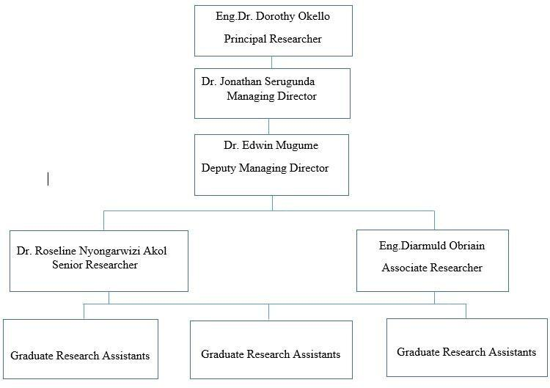The figure 1.1 shows the hierarchical arrangement of lines of authority, communication, rights and duties of an organization. It determines how roles, power and responsibilities are assigned, controlled and how information flows, between the different levels of management. Figure 1.1 shows the organizational structure [3].

Figure 1.1: Organization Structure of netLabs!UG

# CHAPTER TWO: LITERATURE REVIEW

## INTRODUCTION

This chapter introduces the theoretical background and literature review of the work carried out in modules of Python programming, Machine Learning and Embedded systems during the internship period at netLabs!UG. The intern’s relation with field supervisor and other company employees, and the weekly plan.

## POSITION, DUTIES AND RESPONSIBILITIES AT NETLABS!UG

For the internship period, the internee occupied the position of a Post-graduate researcher at netLabs!UG. The following are the main duties and responsibilities that the student undertook during the field attachment at netLabs!UG;

**Python Programming.** The internee learnt the basics and advanced knowledge in the python programming language and used it to develop a student record management system.

**Machine Learning**. The internee was responsible for making machine learning models based on various datasets, tuning and evaluating these models.

**Website development.** The internee used python framework Flask to design websites on which machine learning models were deployed. The websites were sent to the administrators for review.

**Software installations and configurations.** Installation and configuration of software programs on both Linux and Windows platforms on fellow internee’s computers at netLabs!UG. The software included different operating systems, Anaconda IDE, Arduino IDE, VS code, Libraries for both Python and Arduino.

## WEEKLY PLAN

**Table 2.1: The weekly work plan**

|  |  |
| --- | --- |
| **WEEK** | **GOAL** |
| Week 1 | Orientation to netLabs!UG  Software installation and Fundamentals of Python programming language. |
| Week 2 | Object oriented programming  Python project (student record management program) |
| Week 3 | Introduction to machine learning (ML)  Python Libraries for ML  Web development with Flask Framework |
| Week 4 | Presentation of the ML assignment  Introduction to Embedded systems  Arduino board, sensors and actuators |
| Week 5 | ESP32 board  ThingSpeak for virtualization  Firebase for data storage |
| Week 6 | Final internship project  Embedded part of the project  ML part of the project |
| Week 7 | Final project  Web development part of the project  Mock presentation |
| Week 8 | Integrating all parts  Making a project report  Making slides  Making the prototype of the project |

**Table 2.2: Tutors**

|  |  |  |
| --- | --- | --- |
| **Duration** | **Tutor(s)** | **Areas they trained** |
| Week 1 & 2 | Mr. Kalibala Abdunoor | Python Programming |
| Week 3 | Mr. Wayne Okello | Machine learning |
| Week 4 & 5 | Mr. Wayne Okello | Embedded systems |
| Week 6, 7 & 8 | All | Internship Final Project |

## SUPERVISION LEVELS AND RELATIONSHIP WITH SUPERVISOR

### Supervision levels

There are two levels of supervision as stated in Makerere University field attachment policy; the day to day site level supervision by the field supervisor and the visiting academic supervisor. During the visit, the academic supervisor will interact with the student on the field attachment, field supervisor or other relevant officials and also visit the attachment sites to acquaint himself/herself with the activities of the student.

The intern fully underwent both levels of supervision. The onsite field supervisor was a person with relevant practical experience, showed willingness to have regular contact with the internee, was willing to engage in a learning experience and exhibited great ethical and professional conduct. The Academic supervisor communicated to the student about the supervision schedule early enough and the so the student was given enough time to prepare for supervision. When the Academic Supervisor came, he interacted with the student concerning his progress with the field attachment [1].

### Relationship with site supervisor

The relationship with the field supervisor was generally based on the following;

Getting the job done-independently: The field supervisor gave the internee clear direction and expectations. The internee’s responsibility was to carry out assigned tasks, without a lot of direct management. Although there was time and opportunities for learning and processing ideas, the supervisor expected outcomes.

Giving Communication and Feedback: The internee always freely talked to his field supervisor. He could express his needs, challenges, and intentions and always received feedback from the supervisor and the entire staff on netLabs!UG.

Being a good time manager: On days of physical meeting the internee had to ensure that he is at office by 2:00pm ready for work. The field supervisor usually gave time-bound tasks and the internee had to ensure that he beats the deadlines.

Trust, support, and understanding: The field supervisor showed the internee great levels of understanding while working at netLabs!UG.

### Relationship among team members

The issue of TEAM WORK at netLabs!UG was encouraged and the internees exhibited high levels of team work and frequently worked on the same projects, each person working on a smaller module which would then be merged with modules done by other staff to make the whole complete system.

### Authority levels to the student

Although the internee was just a student on internship, staff at netLabs!UG treated him more like a junior colleague at the work place. He was permitted an equitable level of Authority. On a number of projects, he was left to make decisions. Among the students on field attachment, he was given the role of coordinator, in charge of coordinating other internees.

However, even with that level of authority, he was cautioned by his field supervisor to always ensure that he communicates in time and asks for approval before making decisions, especially those that could affect other workmates and internees at the office.

## THE THEORY OF PYTHON PROGRAMMING

Python is a high-level, interpreted programming language known for its simplicity and readability. It was created by Guido van Rossum and first released on February 20th, 1991. Python supports multiple programming paradigms, including procedural, object-oriented, and functional programming. Python is widely used for web development, data analysis, scientific computing, artificial intelligence, and more. Its extensive libraries and active community make it a powerful tool for developers.

### Python Fundamentals

**Syntax:** Python has an easy, clean and readable syntax, which is one of its main strengths. Statements are written on separate lines, and indentation is used to denote code blocks.

**Data Structures:** Data structures in programming refer to the ways in which data is organized, stored, and manipulated in memory. The main data structures include and are shown in figure 3.7;

* **Integers**: Integers are whole numbers, such as -10, 10.
* **Floating-Point Numbers:** Are numbers with decimal points.
* **Booleans**: Booleans represent True or False.
* **Lists:** Lists are ordered collections of items that can be of different data types.
* **Tuples:** they are immutable, meaning that their elements cannot be modified after creation.
* **Sets:** Sets are unordered collections of unique elements.
* **Dictionaries:** are key-value pairs where each value is associated with a unique key.
* **Strings**: are sequences of characters.

**Control Structures:** Control structures in programming allow you to control the flow of execution in your program. They enable you to make decisions, repeat blocks of code, and perform different actions based on specific conditions. In Python, control structures include conditional statements (if-else statements), loops and branching statements as shown in figure 3.8.

**Loops:** These allow you to repeat a block of code multiple times. A for loop is used to iterate over a sequence or any iterable object. It executes a block of code for each item in the sequence. The while loop is used to repeatedly execute a block of code as long as a given condition is True. It is useful when the number of iterations is unknown or depends on a condition. These are shown in figure 3.9.

**Branching Statements:** Branching statements allow you to control the flow of execution within loops or conditional statements. The break statement is used to exit the current loop prematurely and to terminate a loop when a certain condition is met. The continue statement is used to skip the rest of the current iteration and move to the next iteration of a loop [5].

### Advanced Python

**Functions:** A function is a named block of code that performs a specific task. It allows you to encapsulate a set of instructions into a reusable unit, which can be invoked multiple times and in multiple places within the program code and an example is shown in figure 3.11.

**Object-Oriented Programming:** OOP is a programming paradigm that organizes code around objects, which are instances of classes. It provides a way to structure programs by representing real-world entities as objects and defining their properties and behaviors. The key concepts of OOP are Classes, Objects, Inheritance, Polymorphism and Encapsulation.

**File Handling:** File handling in Python allows you to read from and write to files on your computer.

**Modules and Packages:** Modules and packages are an essential part of organizing and reusing code in Python. They allow you to break down your code into separate files and directories, making it easier to manage and maintain large projects.

**Error Handling and Exceptions:** Allows you to handle and recover from unexpected or erroneous situations that may occur during program execution. Python provides a robust mechanism to catch and handle exceptions or errors and prevent your program from crashing.

**Input and Output:** Input and output (I/O) operations are fundamental in any programming language, including Python. They allow you to interact with users, read input from external sources, and display output to the screen or write it to files.

**Debugging and Testing:** Debugging and testing are crucial aspects of software development that help identify and fix errors and ensure the reliability and correctness of your Python programs.

**Follow PEP 8 and Documentation:** PEP 8 is the official style guide for Python code and document your code using comments and docstrings.

**Testing and Test-Driven Development (TDD):** Write unit tests to verify the correctness of your code using test functions.

**Version Control**: Utilize version control systems (such as Git) to track changes to your codebase, collaborate with others, and easily revert to previous versions if needed [5].

### Python Libraries

Python has a vast ecosystem of libraries and frameworks that provide ready-to-use code, tools, and functionalities to enhance your development process and extend the capabilities of Python. Here are some popular libraries and frameworks in Python:

**NumPy:** NumPy is a powerful library for numerical computing, providing support for large, multi-dimensional arrays and matrices, along with a collection of mathematical functions to operate on these arrays efficiently.

**Pandas:** Pandas is a library for data manipulation and analysis. It provides data structures like Data Frames for handling structured data and offers powerful tools for data cleaning, merging, reshaping, and analysis.

**Matplotlib:** Matplotlib is a plotting library for creating static, animated, and interactive visualizations in Python. It provides a flexible and comprehensive set of plotting functions and features for generating high-quality graphs, charts, and figures.

**Scikit-learn:** For machine learning and data mining.

### Web Development with Python:

Python has web frameworks like Flask and Django that simplify web application development. **Flask:** is a micro web framework for Python which is lightweight. Flask is lightweight and minimalistic, providing essential tools to build web applications without unnecessary overhead. Flask supports URL routing, allowing developers to map URL patterns to specific Python functions (called view functions) that handle requests and also supports template rendering for rendering dynamic HTML pages.

### Python in Data Science

Python is used for data analysis, data visualization, and machine learning in the field of data science. Libraries like pandas, Matplotlib, Seaborn, and Jupyter for data science tasks [6].

## MACHINE LEARNING

Machine learning is a branch of artificial intelligence (AI) that allows computers to learn and make predictions or choices without having to be explicitly programmed for each task. It entails developing mathematical models that can learn from data and enhance their performance.

These models are intended to discover patterns, connections, and trends in data and then use that knowledge to create accurate predictions or take appropriate actions. Machine learning often begins with training data, which consists of examples or occurrences from which the model can learn. Each sample is associated with the desired output or goal value, and the data is carefully chosen and tagged. The model then examines the data, looking for trends and altering internal parameters to reduce mistakes and enhance predictions. Several attributes are utilized in training to predict a specific output, which is always referred to as a target value. During our internship, we solely focused on one sort of machine learning, known as supervised machine learning. **Supervised Learning:** The model is trained on labeled data, where both input features and corresponding output labels are provided. The model learns to map input data to the correct output labels, enabling it to make predictions on unseen data. Other types of machine learning include; Unsupervised Learning and Reinforcement Learning.

Machine learning models can be applied to various domains and tasks, including image recognition, natural language processing, speech recognition, recommendation systems, fraud detection, autonomous vehicles, and many others. As models are exposed to more diverse and representative data, their performance and generalization capabilities tend to improve.

### Steps in the Machine Learning Process

**Research Question Selection:** This entails precisely articulating the study's goal and deciding on the specific task you want the machine-learning model to execute, such as classification, regression, or clustering. The phase of research question selection determines the overall course of the study. Nonetheless, a research issue may arise when the data is available or during Exploratory Data Analysis (EDA).

**Data collection:** In thisstep relevant data is gathered to serve as the foundation for training and evaluating the model.

**Exploratory Data Analysis (EDA):** This is the visual and statistical exploration of data to obtain insights and uncover patterns, trends, and relationships. It entails producing summary statistics, making infographics, and transforming data. EDA assists you in understanding the data, detecting anomalies, and making informed judgments about feature selection, data transformations, and potential modeling difficulties. Scatter graphs, boxplots, histograms, and other visualization are used.

**Data pre-processing:** it includes cleaning the data, handling missing values, scaling features, and converting categorical data to numerical formats. Here various libraries are applied to achieve this imported from the sklearn.preporcessing module.

**Feature engineering:** is then performed to extract meaningful features according to the topic of research and the required output from raw data and dropping the columns that are not required and those that contributed to the desired output.

**Model selection:** takes place, where the appropriate machine learning algorithm is chosen based on the problem and data at hand.

**Model training:** involves feeding the algorithm with the training data to learn the underlying patterns. The desired problem maybe a classification or a regression problem hence the algorithm used is chosen depending on the desired output.

**Model evaluation:** is done using validation or test data to ensure its effectiveness. Model tuning fine-tunes hyper parameters to optimize the model's performance further. We used the the accuracy score, classification table and the confusion matrix to evaluate the various ML models that we trained, and after this step we chose the best algorithm to use on a specific problem.

Once the model is satisfactory, it can be deployed in real-world applications to make predictions on new data [7].

### Common Machine Learning Algorithms

* Linear regression
* Support vector machines (SVM)
* Classification algorithm
* Support vector machines
* Decision trees
* Random forests
* Neural networks.
* KNN K- Nearest Neighbor [8]

## EMBEDDED SYSTEMS

Computer systems built to execute specialized activities or functions within bigger systems or devices are referred to as embedded systems. These systems are often specialized to a single function and are integrated into a larger electronic equipment or product. They are meant to work in real time and frequently have restricted processing power, memory, and energy usage.

They are made up of a combination of hardware and software components that work together to perform specified functions, and several programming languages, depending on the individual hardware and software platform, are often utilized.

They can be found in a variety of products and applications, such as consumer electronics, automotive systems, medical equipment, industrial control systems, and smart appliances.

**Hardware**

An embedded system's hardware often contains micro-controllers or microprocessors; these are the embedded system's central processing units (CPUs), which are responsible for executing software instructions and regulating the system's functions. Then there's memory, I/O interfaces (sensors and actuators), and power management circuitry.

**Software**

The firmware, application software, development tools, and computer code that governs the system's behavior and executes the desired functions are all part of the software component.

The key properties of embedded systems are dependability, efficiency, real-time operation, and, in many cases, autonomy. They are designed to meet specific criteria and limits imposed by the application and the system's environment systems, such as power consumption, size, and performance.

**Basic Structure of an Embedded System**

The figure 2.1 shows the basic structure of the embedded system

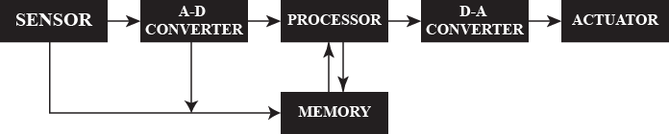

Figure 2.1: Structure of an embedded system

### Arduino IDE

The Arduino IDE is a free and open-source platform for creating electronic projects. The Arduino IDE is installed on your computer. Through the IDE, a user can write, test, compile, run, and upload computer code to the physical board.

### Development Boards

Embedded system development boards are platforms that are specifically designed to make embedded system development and prototyping easier. These boards often have integrated microcontrollers or microprocessors, a variety of built-in peripherals, and programming and debugging support. Here are a few examples of popular embedded system development boards:

1. **Arduino**

Arduino boards are well-known and popular among embedded system developers and hobbyists. They are built around Atmel AVR or ARM microcontrollers and provide a straightforward and user-friendly development environment. Arduino boards are available in a variety of form factors, including the Arduino Uno, Arduino Nano, and Arduino Mega, and offer a variety of features and capabilities. An example of a development board is shown in figure 2.2.

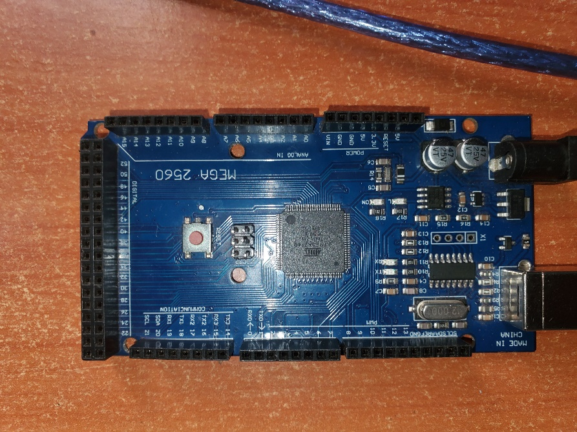

Figure 2.2: Arduino Mega Development Board

1. **ESP8266/ESP32**

The ESP8266 and ESP32 development boards are highly popular for Internet of Things (IoT) projects. These boards feature built-in Wi-Fi and Bluetooth capabilities, making them suitable for wireless communication applications. They are often used for home automation, sensor networks, and IoT prototyping as shown in figure 2.3.

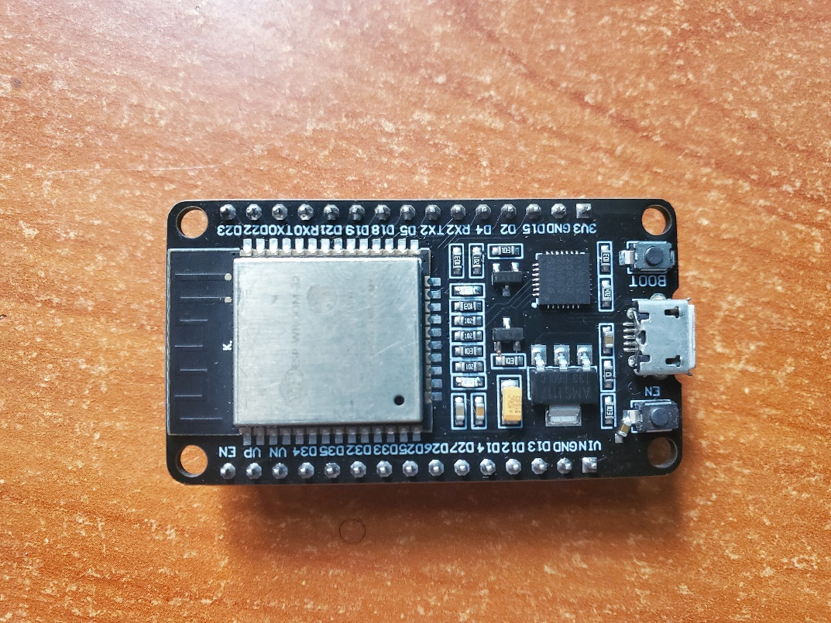

Figure 2.3: ESP32 Development Board

### Sensor

A sensor is a device that generates an output signal in order to detect a physical phenomena. A sensor is a device, module, machine, or subsystem that detects events or changes in its surroundings and transmits the data to other electronics, most commonly a computer processor.

A sensor translates physical signals such as temperature, pressure, light intensity, motion, and so on into matching electrical impulses that the system can process. Temperature sensors, pressure sensors, motion sensors, and many other types of sensors are available. Sensor data offers crucial input to the embedded system, allowing it to make judgments and take necessary actions. Here are several examples [8]:

**Table 2.3: Sensors**

|  |  |  |
| --- | --- | --- |
| C:\Users\okiro\AppData\Local\Microsoft\Windows\INetCache\Content.Word\20230802_065906.jpg  Figure 2.4: Digital Humidity and Temperature (DHT) | **C:\Users\okiro\AppData\Local\Microsoft\Windows\INetCache\Content.Word\ultra sonic (2).jpg**  Figure 2.5: Ultrasonic sonar sensors | C:\Users\okiro\Desktop\My PC\Personal\Samuel\pics\PIR sensor.jpg  Figure 2.6: Passive Infrared (PIR) sensors |

**Digital Humidity and Temperature (DHT):** The sensor is a type of digital sensor used to measure humidity and temperature in the surrounding environment as show in figure 2.4 [9].

**Ultrasonic sonar sensor:** Ultrasonic sensors use sound waves at frequencies beyond the human hearing range as shown in figure 2.5 [10].

**Passive Infrared (PIR) sensor:** are motion detection sensors that detect changes in infrared radiation emitted by objects in their field of view as shown in figure 2.6.

### Actuator

A component that translates electrical information from the embedded system into some other sort of energy or physical action is known as an actuator. Actuators are required for the system's decisions to have real-world consequences. Actuators are critical in converting an embedded system's output into tangible actions or changes in the environment, completing the feedback loop between the system and its surroundings. Actuators that are commonly used include:

**Table 2.4: Actuators**

|  |  |  |
| --- | --- | --- |
| 20230829_143551  Figure 2.7: LCD | 20230829_143655  Figure 2.8: Relay switch | 20230829_144333  Figure 2.9: Water Pump |

|  |  |  |
| --- | --- | --- |
| buzzer  Figure 2.10: Buzzer | 20230829_143809  Figure 2.11: LEDs |  |

## FINAL INTERNSHIP PROJECT

The project was about coming up with a smart irrigation system based on an ESP32 boards with several sensors and actuators plus a machine learning model then all deployed on a web application. The project had three parts;

**Embedded System Design**

The embedded part included the following components;

|  |  |  |  |  |
| --- | --- | --- | --- | --- |
| Figure 2.12: Water Pump | Figure 2.13: Resistive Soil Moisture Sensor Module | | 20230829_143551  Figure 2.14: 20x4 Display LCD Module | |
| 20230829_143611  Figure 2.15: ESP32 Development Board | | 20230829_144114  Figure 2.16: Submersible Digital Temperature Sensor | | 20230829_143824  Figure 2.17: LDR Light Dependent Resistor GL5506 |

The ESP32 microcontroller board is configured to collect soil moisture, temperature and light intensity readings using Resistive Soil Moisture Sensor Module, Submersible Digital Temperature Sensor and LDR Light Dependent Resistor GL5506 respectively. The incoming sensor readings should be displayed on a 20x4 Display LCD Module and a water pump should be configured for actuation purposes.

The data collected from the sensors is to be logged with a real-time database e.g. Firebase to log sensor data and develop logic on the ESP32 to autonomously control the actuators (water pump and irrigation valves) based on the ML model's irrigation predictions. Finally the system should be controlled remotely using Bluetooth communication on the ESP3 [8].

# CHAPTER THREE: PRACTICAL ACTIVITIES

## INTRODUCTION

This chapter contains the practical work done during the internship period including the final internship project and the evaluation of the entire field attachment period, including details of activities accomplished, benefits derived, skills gained, and challenges encountered.

## SOFTWARE DOWNLOAD AND INSTALLATION

Software needed during the internship was downloaded and installed on every internee’s laptop and theses software were; Python, Anaconda IDE, visual studio IDE, Arduino IDE.

**Python:** Python was downloaded by navigating to <https://www.python.org/downloads/>, and downloaded the latest windows version of the python as seen in Figure 3.1.

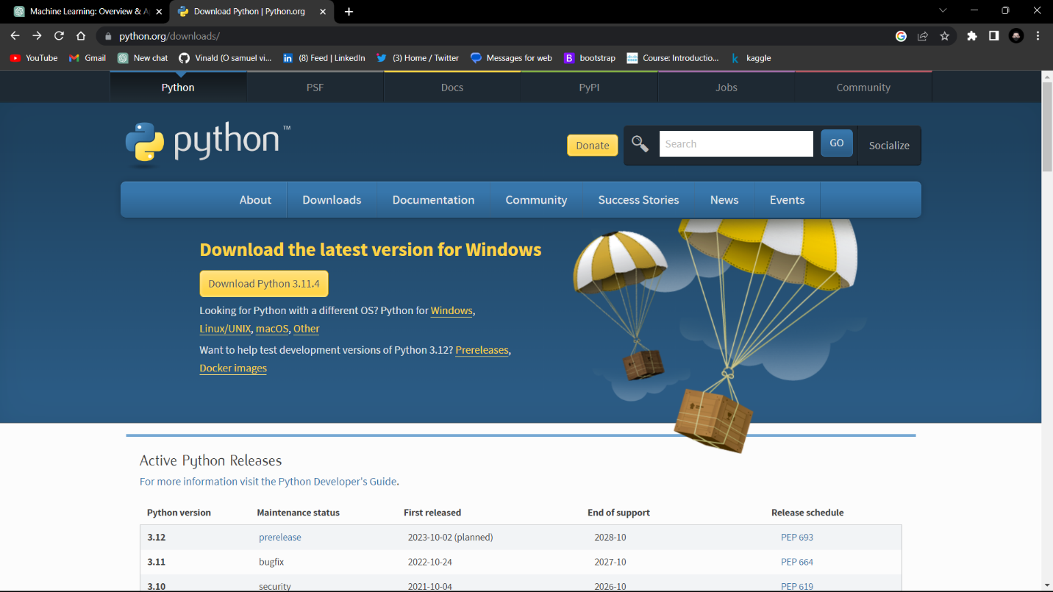

Figure 3.1: Downloading Python

After downloading we installed Python and added it into our system environments variables as shown in figure 3.2.

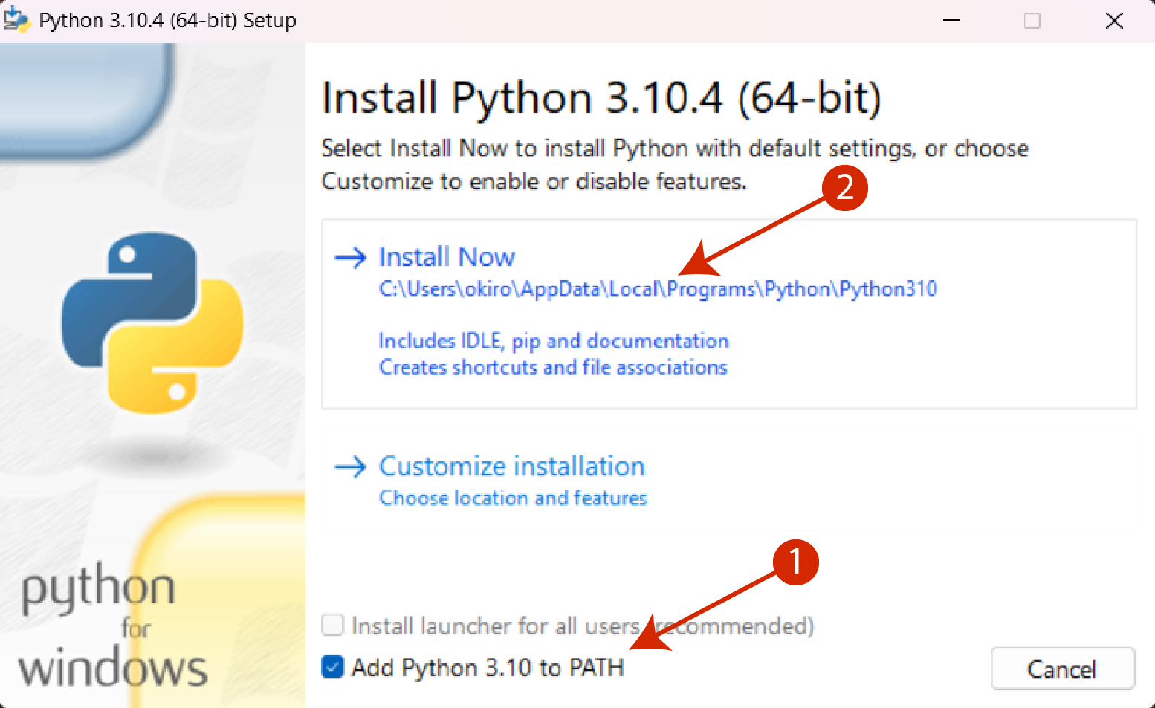

Figure 3.2: Installing Python

**Step 1:**  Add Python into the environment variables

**Step 2:** Follow the installation wizard until the screen that displays finished installation.

**Visual studio Integrated Development Environment (VS code):** VS code is a IDE used to write, edit, run and save code of various programming languages and can be downloaded by navigating on the link <https://code.visualstudio.com/download> as shown in figure 3.3.

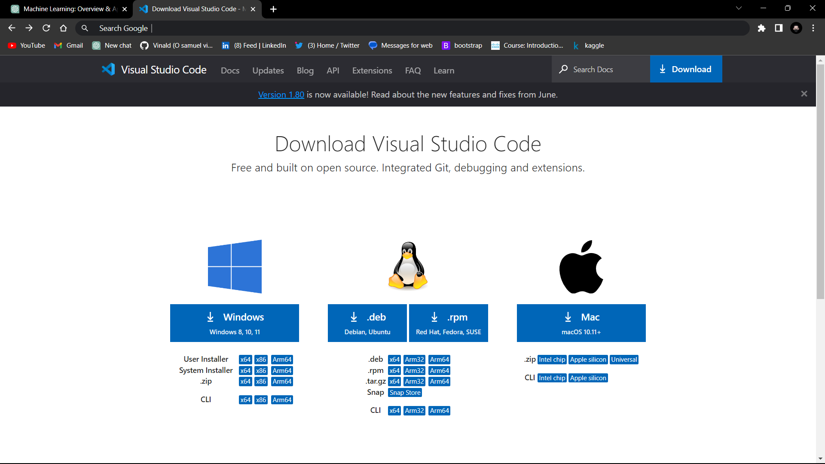

Figure 3.3: Downloading VS Code

After downloading install the software by navigating to where the downloaded file is and following the installation wizard.

**Anaconda navigator**

Anaconda Navigator is a graphical user interface (GUI) included in the Anaconda distribution, which is a popular Python distribution for data science and machine learning. Anaconda Navigator provides a convenient way to manage and launch various data science tools and environments.

This can be downloaded by following this link <https://www.anaconda.com/> as shown in figure 3.4.

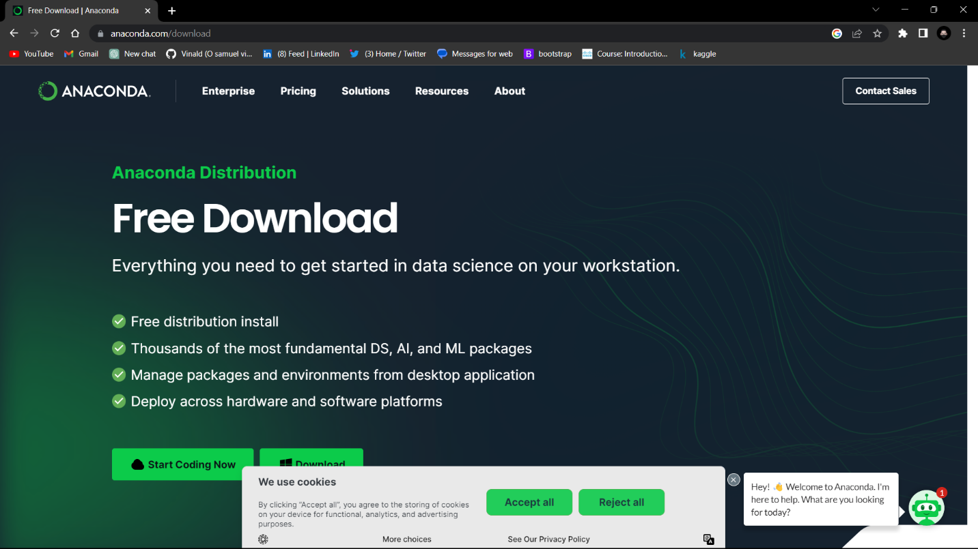

Figure 3.4: Downloading Anaconda

**Arduino IDE**

The Arduino IDE can be downloaded by following the link <https://www.arduino.cc/en/software> as shown in figure 3.5.

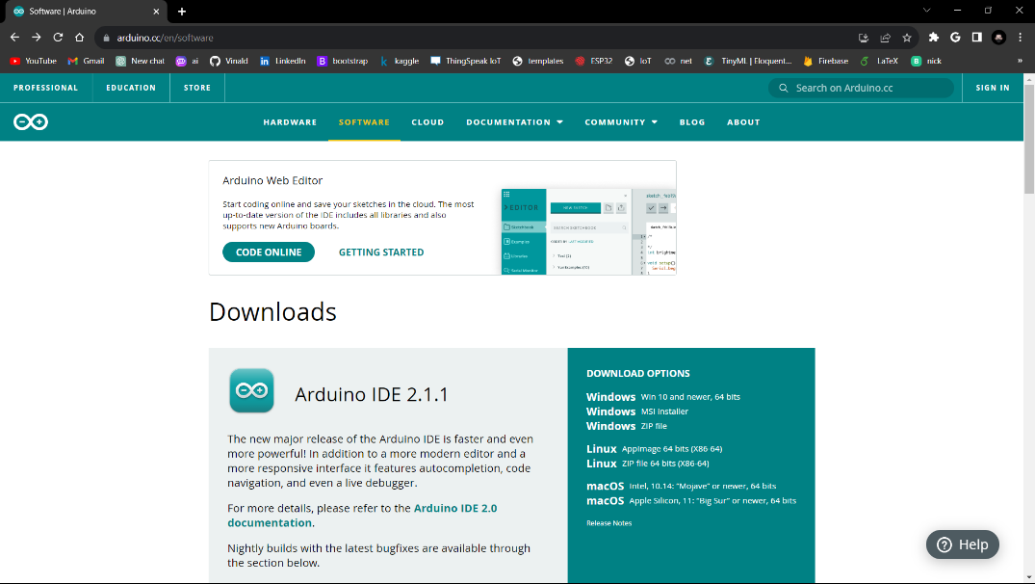

Figure 3.5: Downloading Arduino IDE

## PYTHON FUNDAMENTALS

The internship began with the Python programming language which we learnt using the VS code IDE which has different sections for different purposes as shown in figure 3.6;

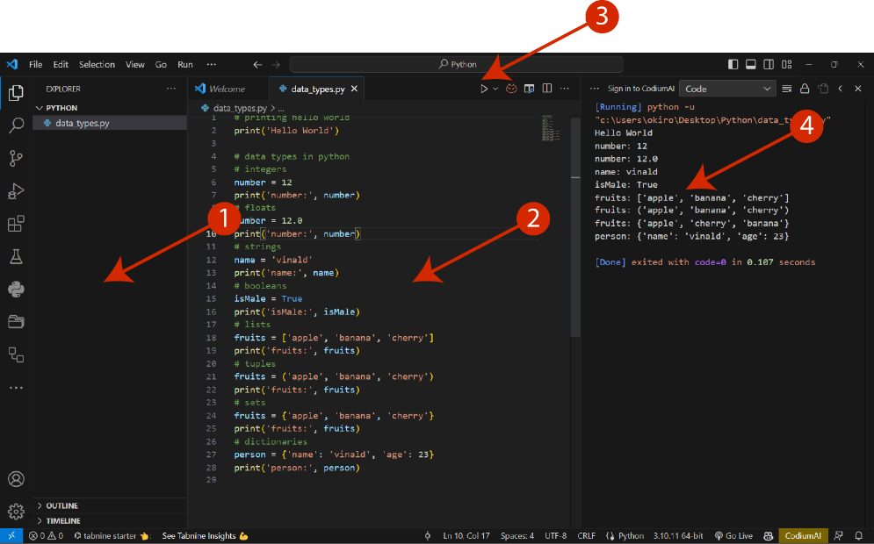

Figure 3.6: Sections of Visual Studio Code IDE

**Section 1:** this area is for creating folders and files like in the figure 24 with a folder called python and a python file called data\_types.py.

**Section 2:** this is the editor where code is written, edited and debugged.

**Section 3:** this is the run button used to execute a python file.

**Section 4:** this is the terminal where outputs are displayed when a python file is run.

### Data Structures and data types

Data structures in programming refer to the ways in which data is organized, stored, and manipulated in memory as seen in figure 3.7.

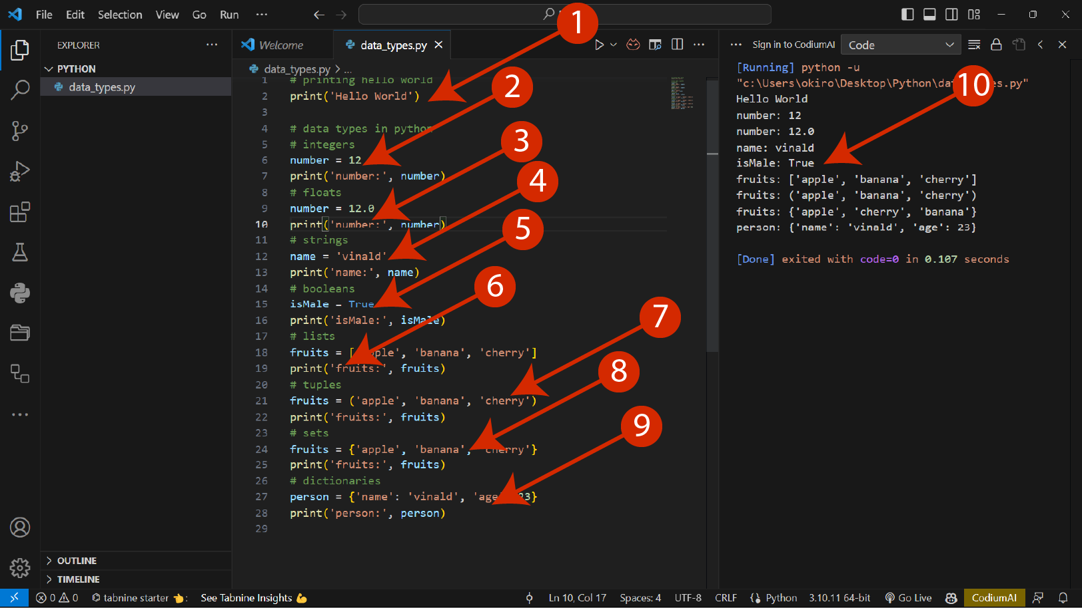

Figure 3.7: Data Structures

The different data structures shown in figure 3.7 are;

1. Running the first program called Hello World
2. **Integers**: Integers are whole numbers, such as -10, 10 and also shows a variable.
3. **Floats:** Are numbers with decimal points.
4. **Strings**: are sequences of characters.
5. **Booleans**: Booleans represent True or False.
6. **Lists:** Lists are ordered collections of items that can be of different data types.
7. **Tuples:** they are immutable, meaning that their elements cannot be modified after creation.
8. **Sets:** Sets are unordered collections of unique elements.
9. **Dictionaries:** are key-value pairs where each value is associated with a unique key.
10. **Output:** this is the output for all the code in the editor, code=0 means execution was successful.

### Control Structures

We covered the various control structures in Python which are the conditional statements (if-else), loops and branching statements. Figure 3.8 shows the If statements.

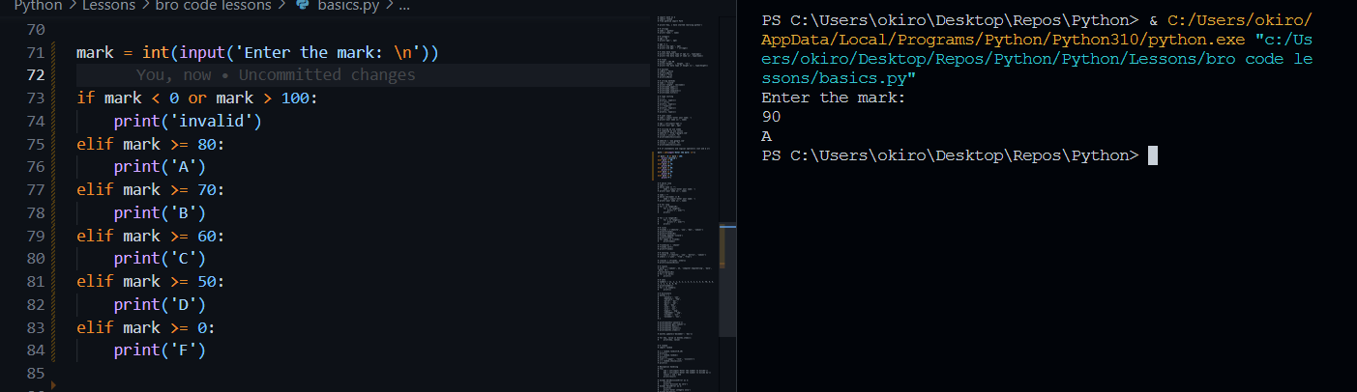

Figure 3.8: Control Statements

### Loops

We covered for loop and the while loop which are used to iterate through a given piece of code until the condition becomes false as seen in figure 3.9.

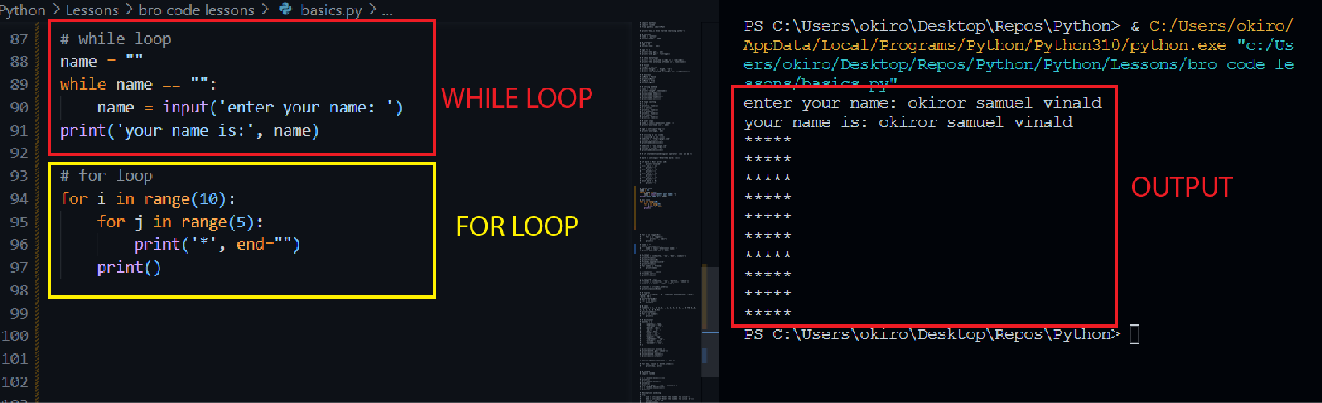

Figure 3.9: Loops

### Branching Statements

Under branching statements we covered the break and continue statements are shown in figure 3.10.

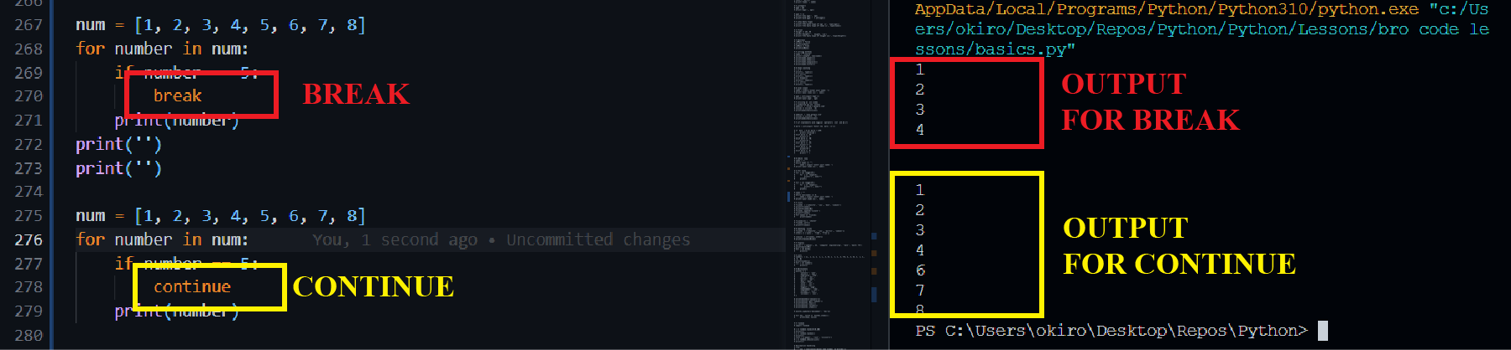

Figure 3.10: Branching Statements

## ADVANCED PYTHON

### Functions

A function is a named block of code that performs a specific task. It allows you to encapsulate a set of instructions into a reusable unit, which can be invoked multiple times and an example is show in figure 3.11.

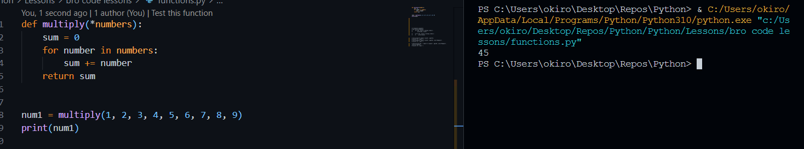

Figure 3.11: Function

### Object-Oriented Programming

OOP is a programming paradigm that organizes code around objects, which are instances of classes. It provides a way to structure programs by representing real-world entities as objects and defining their properties and behaviors. The key concepts of OOP are Classes, Objects, Inheritance, Polymorphism and Encapsulation.

**Modules and Packages:** Modules and packages are an essential part of organizing and reusing code in Python. They allow you to break down your code into separate files and directories, making it easier to manage and maintain large projects. In figure 3.12 the max.py calls the find \_max function from the convertor.py and uses it to find the max number.

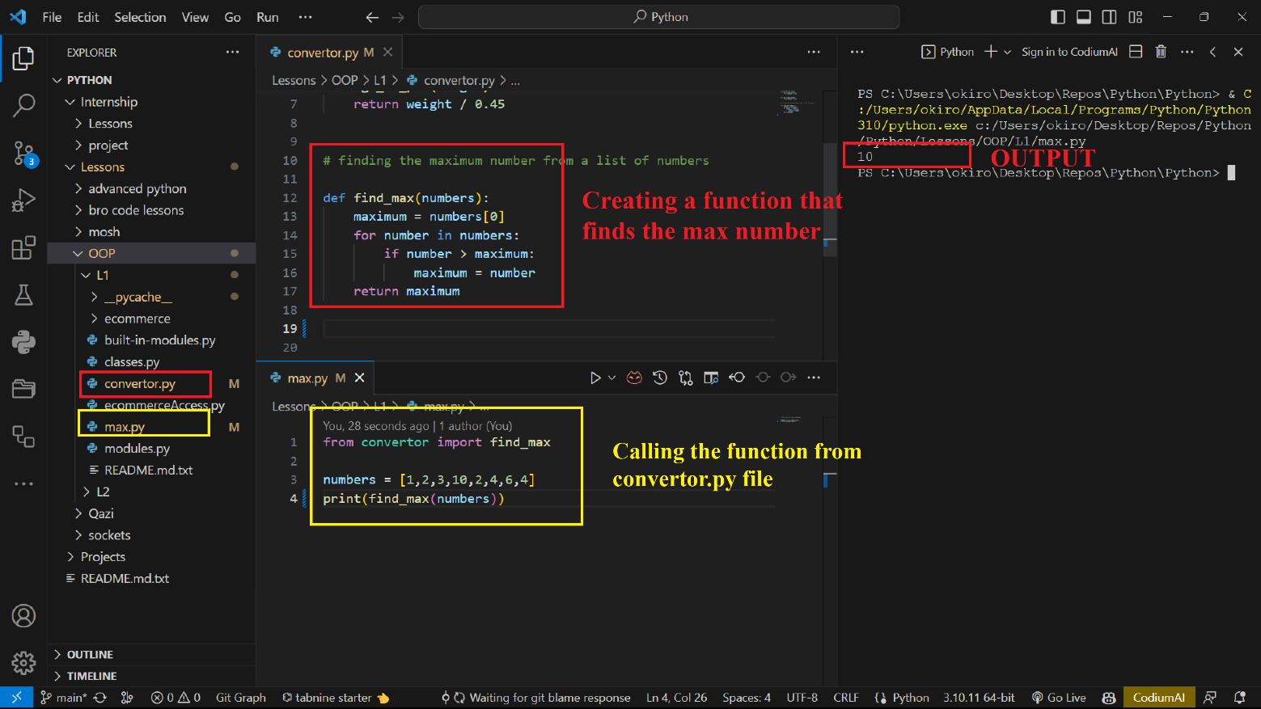

Figure 3.12: Object Oriented Programming

### Error Handling and Exceptions

Allows you to handle and recover from unexpected or erroneous situations that may occur during program execution. Python provides a robust mechanism to catch and handle exceptions or errors and prevent your program from crashing as shown in figure 3.13 where several errors are handled.

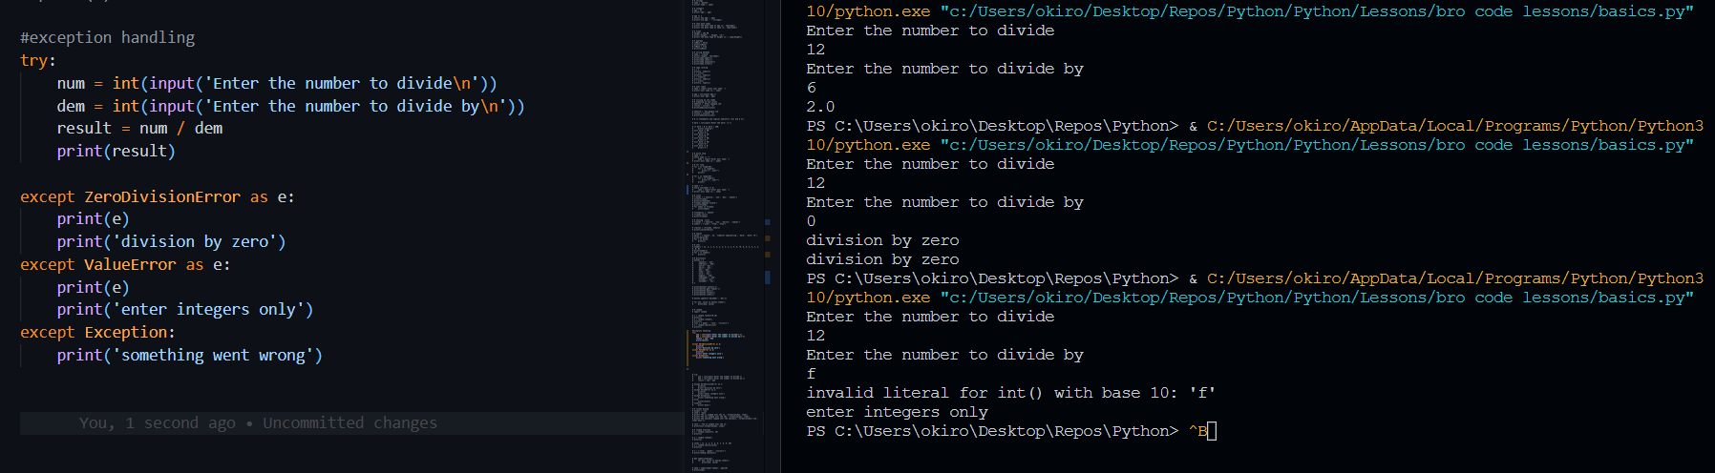

Figure 3.13: Error Handling

### Input and Output

Input and output (I/O) operations are fundamental in any programming language, including Python. They allow you to interact with users, read input from external sources, and display output to the screen or write it to files.

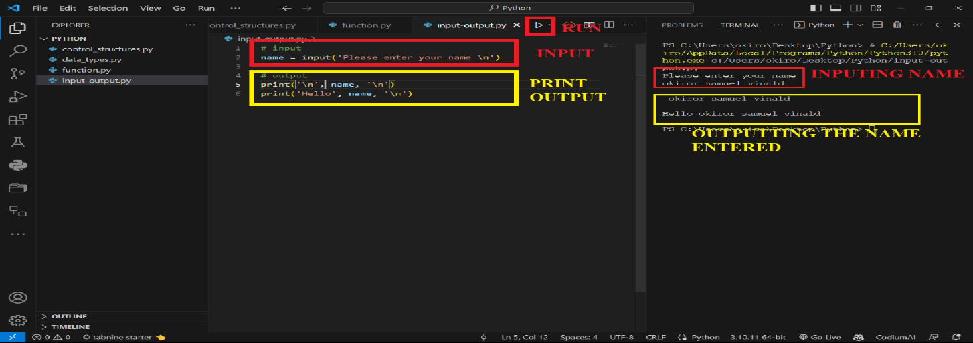

Figure 3.14: Input and Output

**Documentation:** Document your code using comments and docstrings as seen in the figure 3.15.

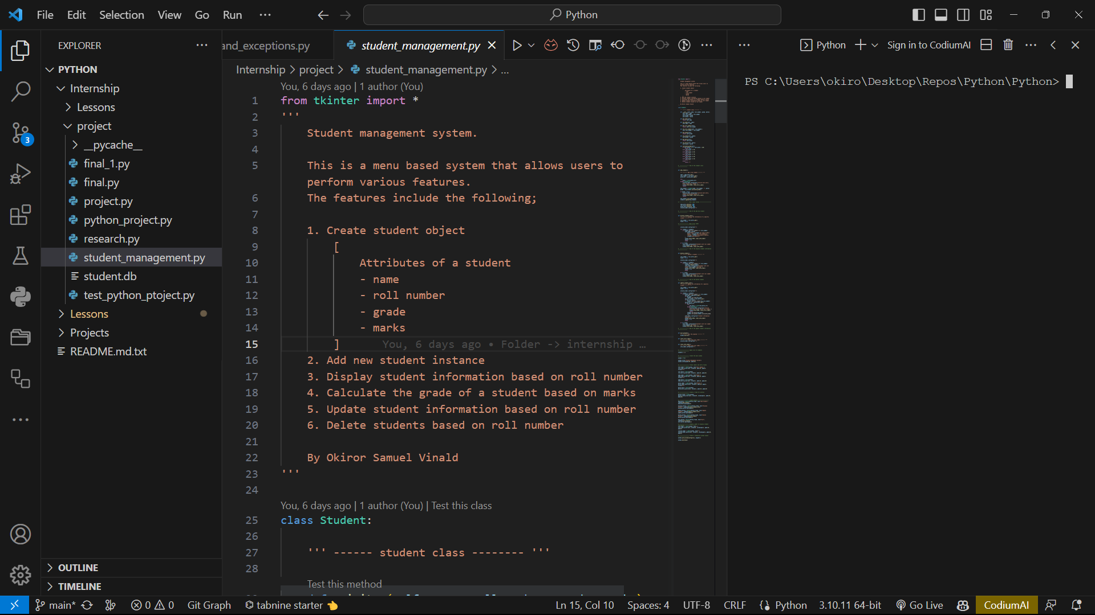

Figure 3.15: Documentation

### Version Control

Utilize version control systems (such as Git) to track changes to your codebase, collaborate with others, and easily revert to previous versions if needed. Figure 3.16 shows a github page for tracking the internship work and project.

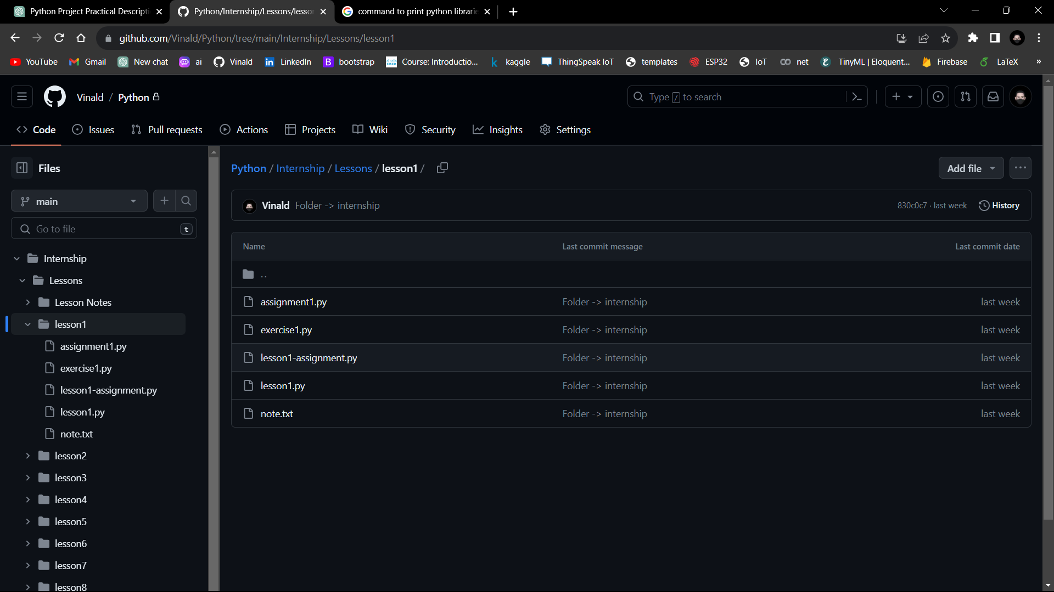

Figure 3.16: GitHub page

### Student record management System

This was a menu based system that allows users to perform various features on students in an institution which include; Create student object (Attributes of a student; name, roll number, grade, marks), Add new student instance, Display student information based on roll number, Calculate the grade of a student based on marks, Update student information based on roll number, and Delete students based on roll number.

Figure 3.17 shows the student class which is the main class that is used to create a student instance with different attributes.

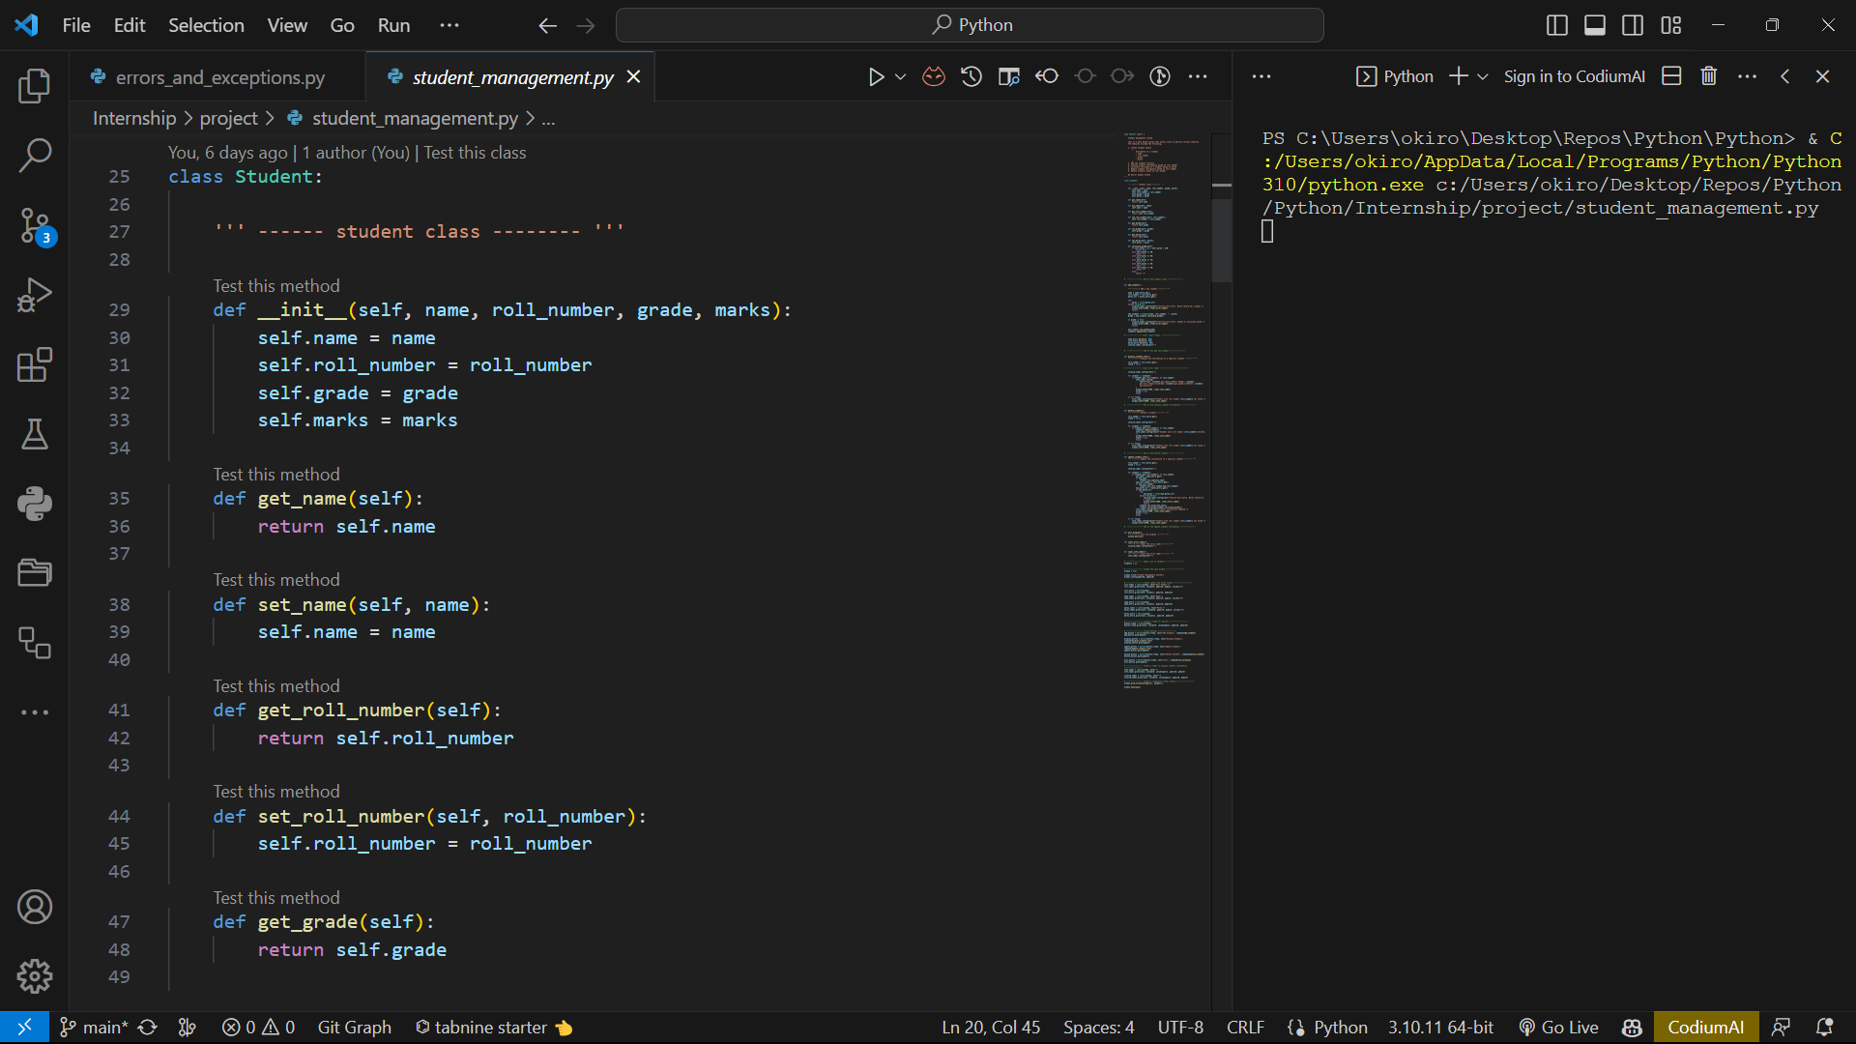

Figure 3.17: Student Class for the Project

An administrator can add a new student to the system by adding the roll number, name, and the mark the press the add student button as shown in the figure 3.18.

An administrator can show student records from system by specifying the roll number and press the display student button and a feedback will be displayed at the bottom showing the student information as shown in the figure 3.19.

An administrator can delete student records from system by specifying the roll number and press the delete student button and a feedback will be displayed at the bottom showing the student who has been deleted as shown in the figure 3.20.

|  |  |  |
| --- | --- | --- |
| C:\Users\okiro\AppData\Local\Microsoft\Windows\INetCache\Content.Word\Screenshot (19).png  Figure 3.18: Adding a Student | C:\Users\okiro\AppData\Local\Microsoft\Windows\INetCache\Content.Word\Screenshot (16).png  Figure 3.19: Displaying a Student | C:\Users\okiro\AppData\Local\Microsoft\Windows\INetCache\Content.Word\Screenshot (17).png  Figure 3.20: Deleting a Student |

## MACHINE LEARNING

Machine learning was covered using python programming language and Anaconda IDE particularly the Jupyter lab and Jupyter notebook for writing and running code. To activate the Jupyter lab, open anaconda terminal and type Jupyter lab, the terminal runs the code as shown in figure 3.21 and it outputs a link which when click opens a web page in the default web browser as shown in figure 2.22.

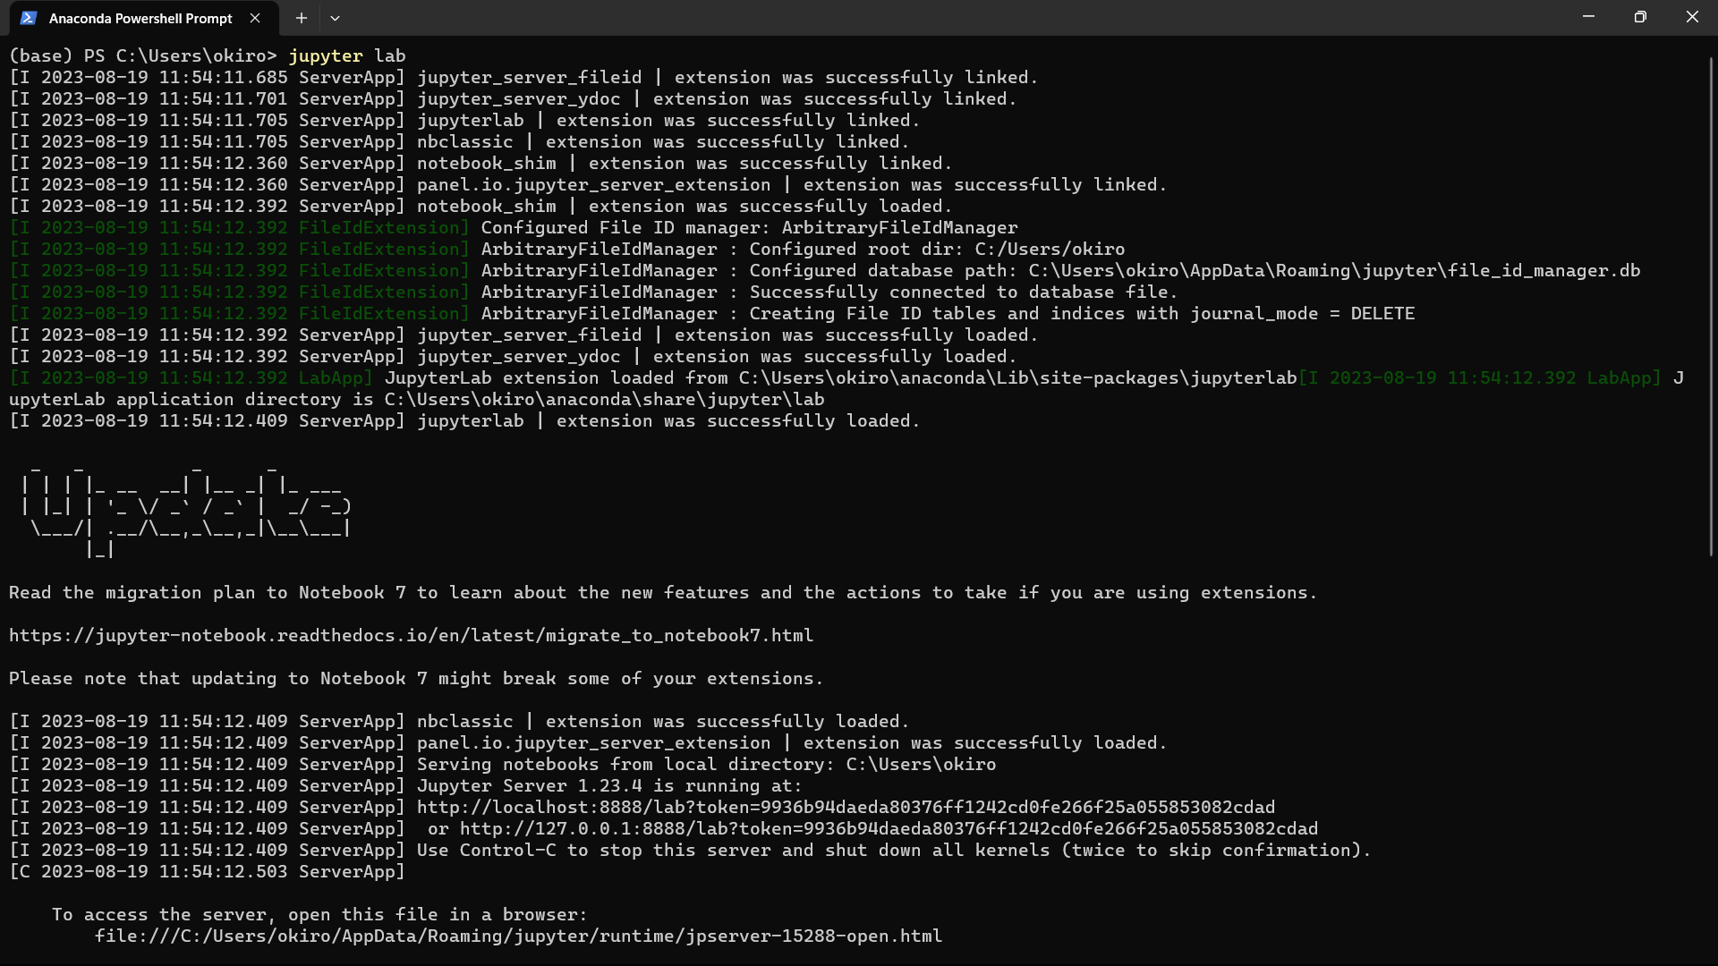

Figure 3.21: Loading Jupyter Lab

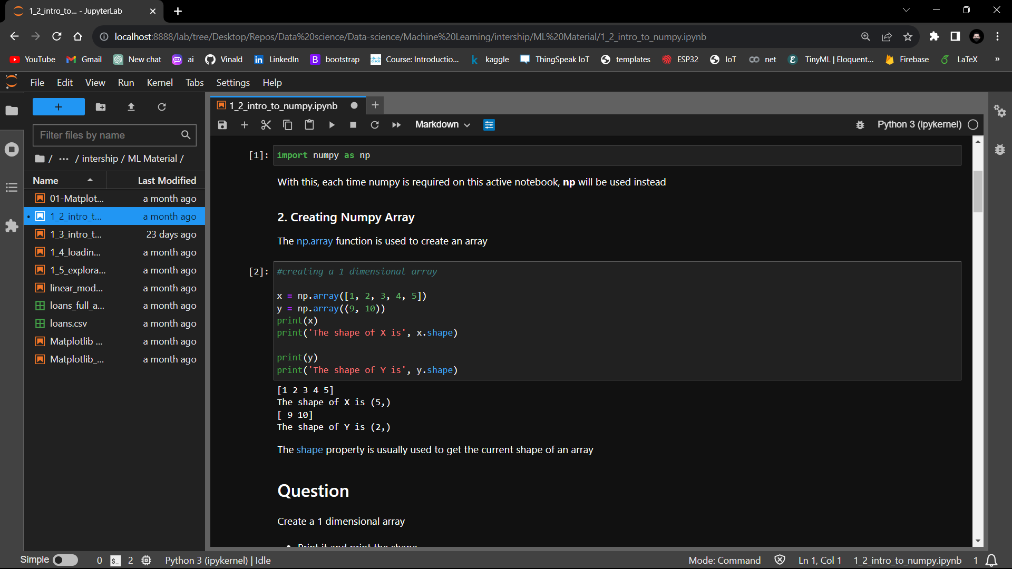

Figure 3.22: Opening Jupyter Lab in the Chrome web browser

### Steps in machine learning

**Research Question Selection:** The research question used was making a loan prediction depending on the amount and repayment term.

**Data collection:** The data used was a provided data set collected by people for several years and the data set was called the loans.csv and was imported into the juypter lab using the libraries imported as seen in figure 3.23 and then the loading of the loans.csv data set as seen in figure 3.24.

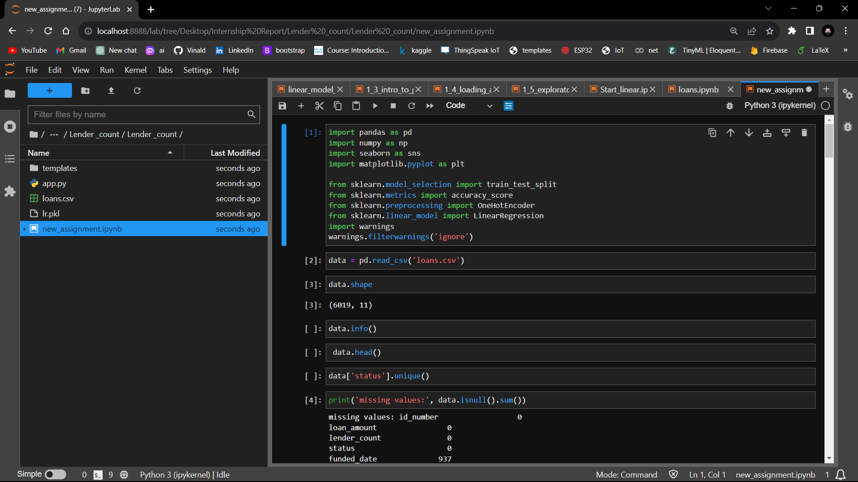

Figure 3.23: Loading Libraries

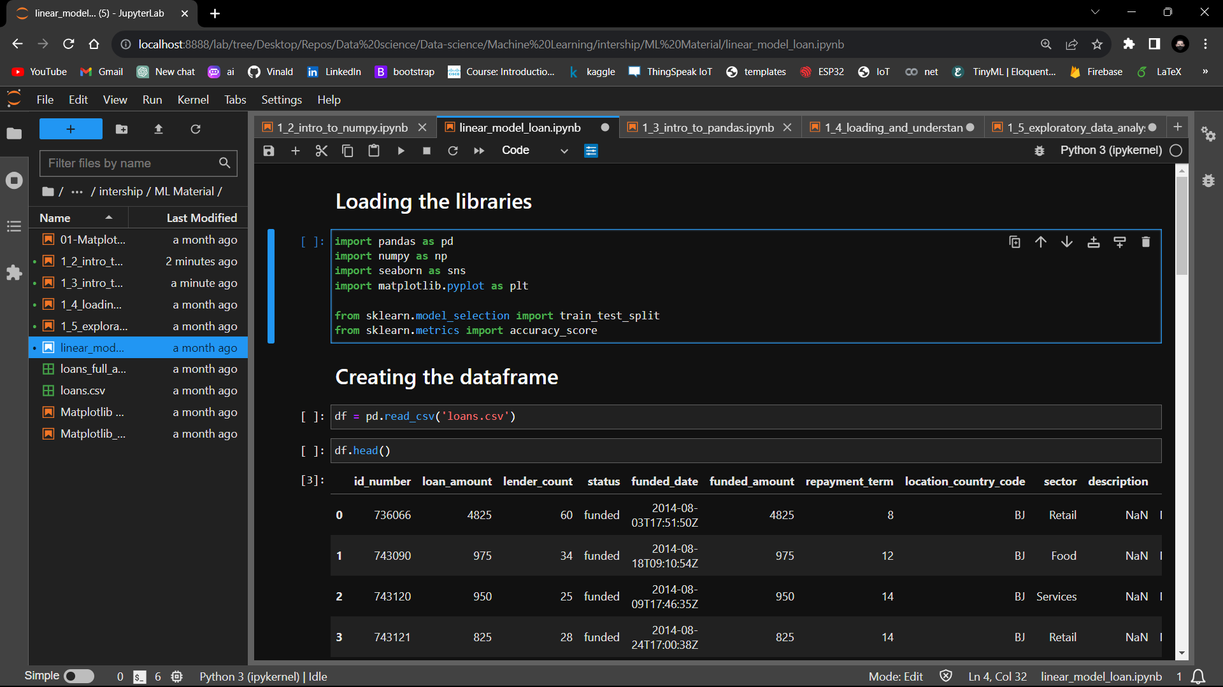

Figure 3.24: Loading the Loans.csv dataset

**Exploratory Data Analysis (EDA):** The EDA was done to get the insight of the data set through use of the Pandas, Seaborn and amatplotlib libraries.

The different features and records are checked and displayed as shown in figure 3.25.



Figure 3.25: The head() function

Then missing records are checked as seen in figure 3.26.

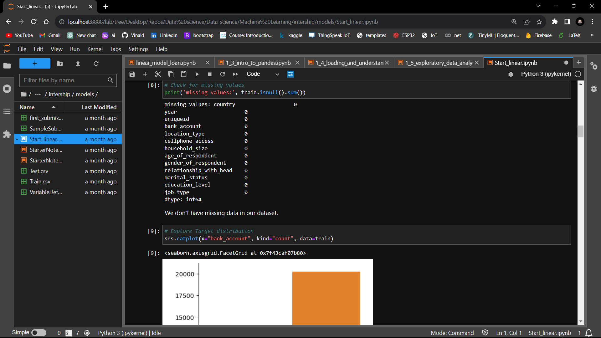

Figure 3.26: Checking for missing records

Then relations between different features can be seen by plotting different graphs as an example is seen in figure 3.27.

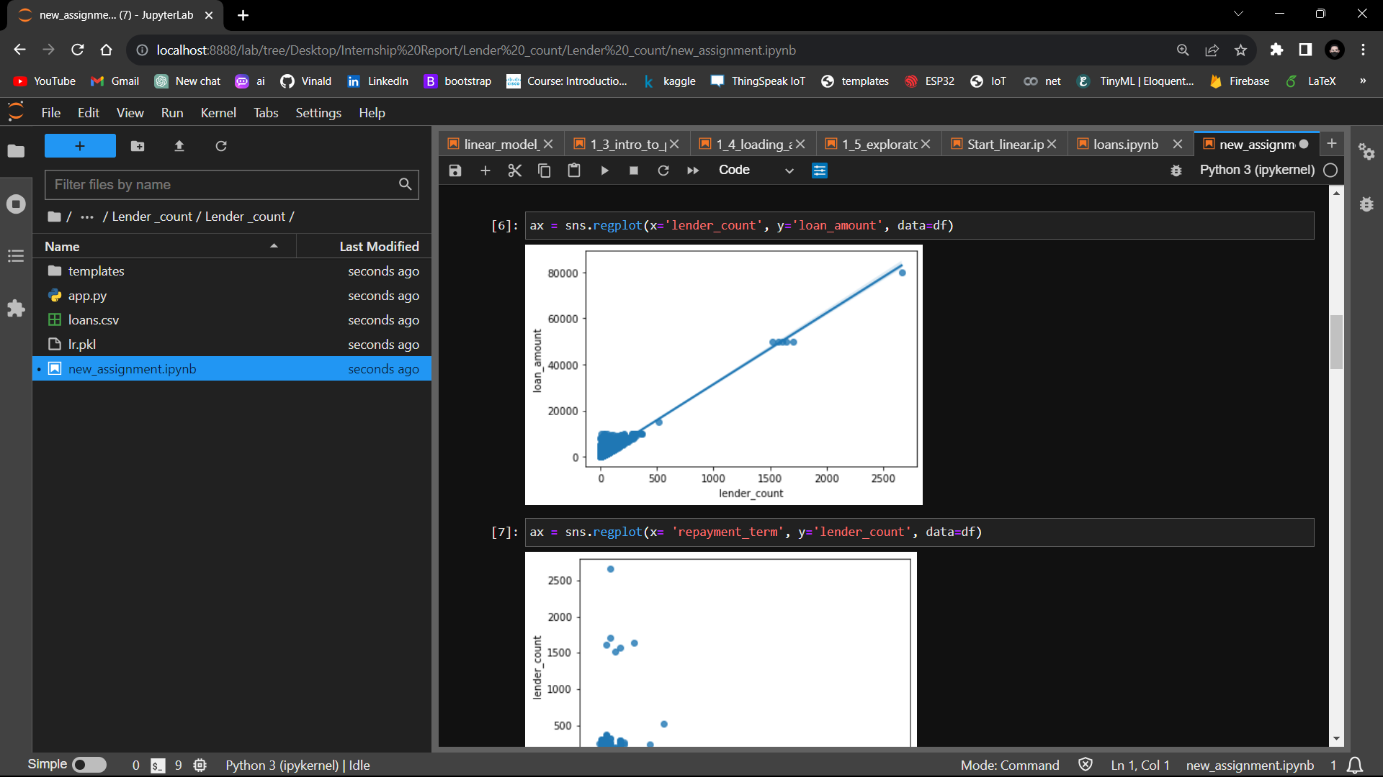

Figure 3.27: Plot of lender against loan amount

**Data pre-processing:** Since we had no missing data and the output column was non numerical a preprocessing was done to convert this feature into 1s and 0s as seen in figure 3.28.

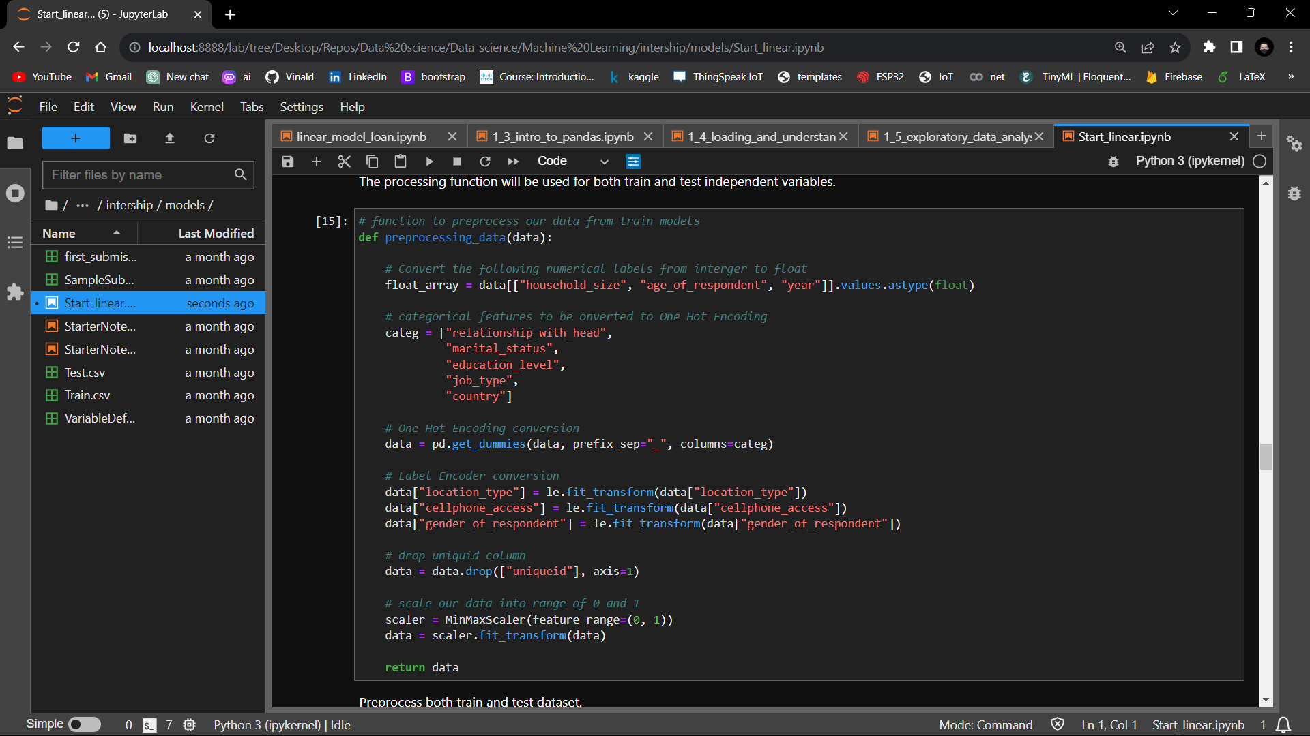

Figure 3.28: Preprocessing

The was followed by splitting the data into training testing and validation data sets as seen in the figure 3.29.

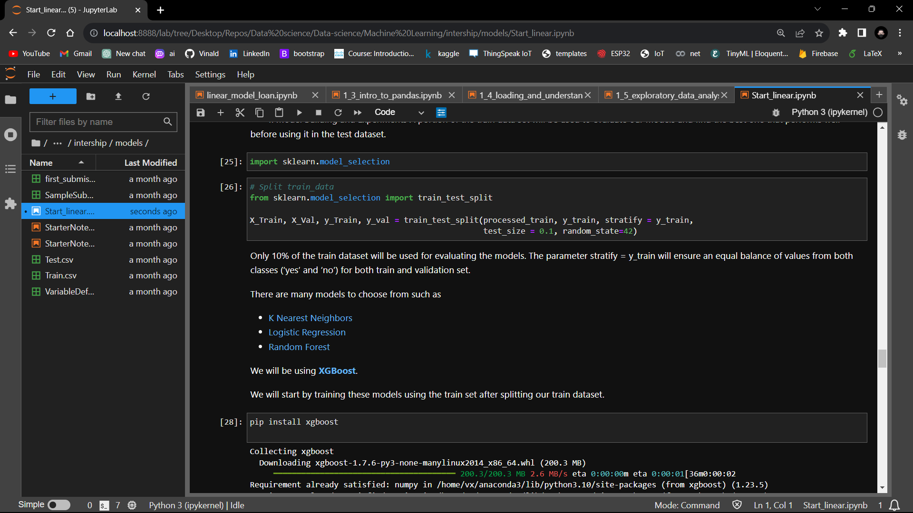

Figure 3.29: Splitting data

**Model building:** this step different algorithms were used and the best one considered to train for the final model saved into a reusable pickle format as shown in figure 3.30 and figure 3.31.

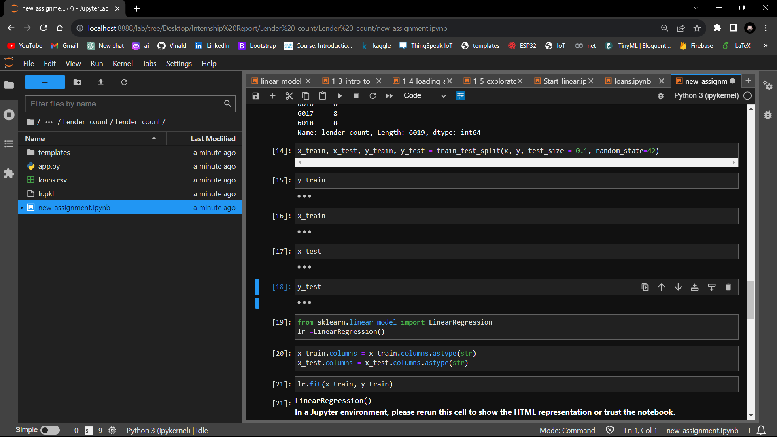

Figure 3.30: building the model

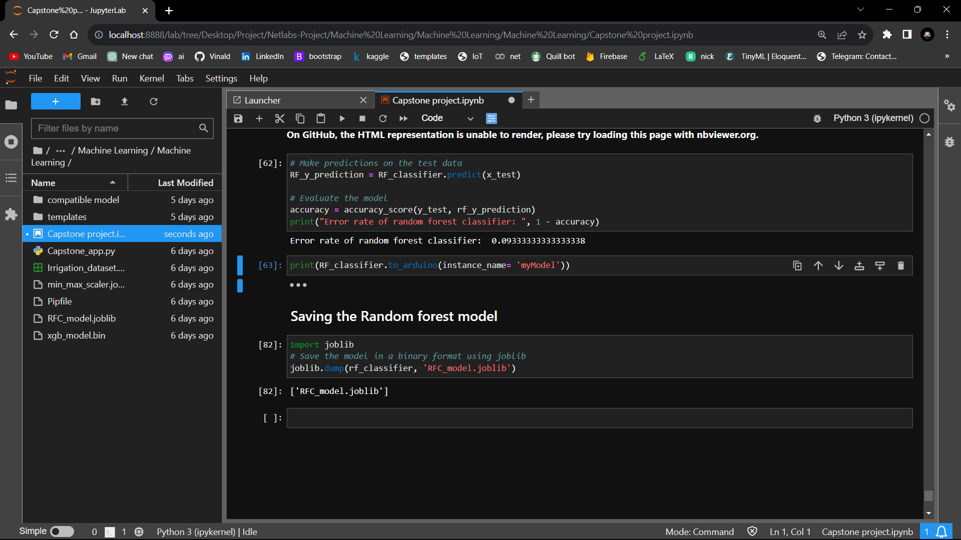

Figure 3.31: Saving a model locally

**Model evaluation:** the model built was evaluated using the accuracy score and the confusion matrix as shown in figure 3.32.

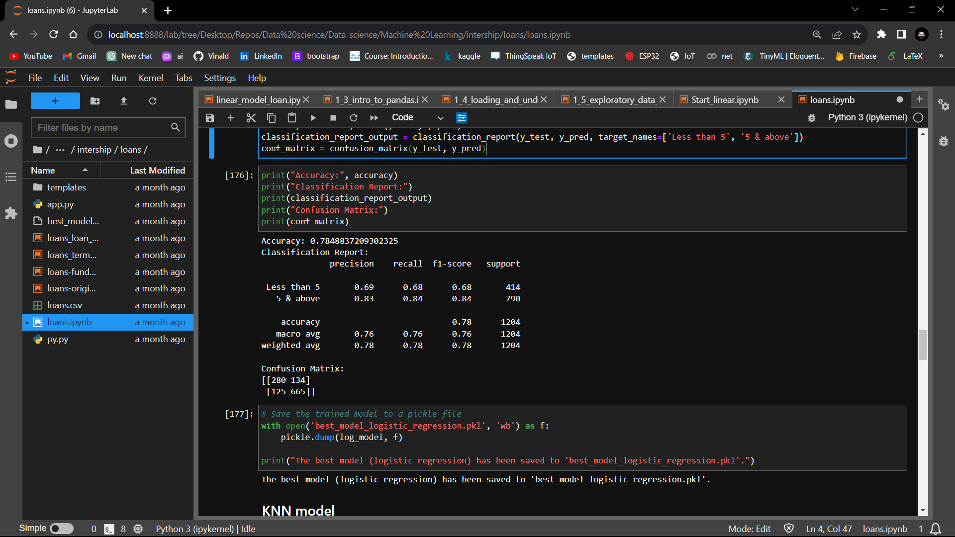

Figure 3.32: Model Evaluation

### Deploying:

After training and evaluating the model, the model is then sent out to the actual world to interact with new data by deploying on a web application as shown in figures 3.33 for python code and figure 3.34 with HTML.

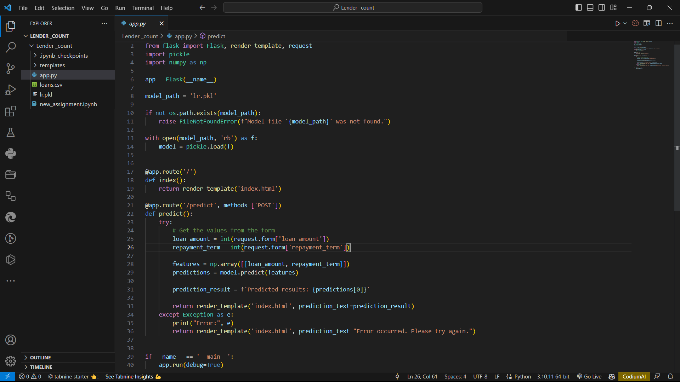

Figure 3.33: Flask code

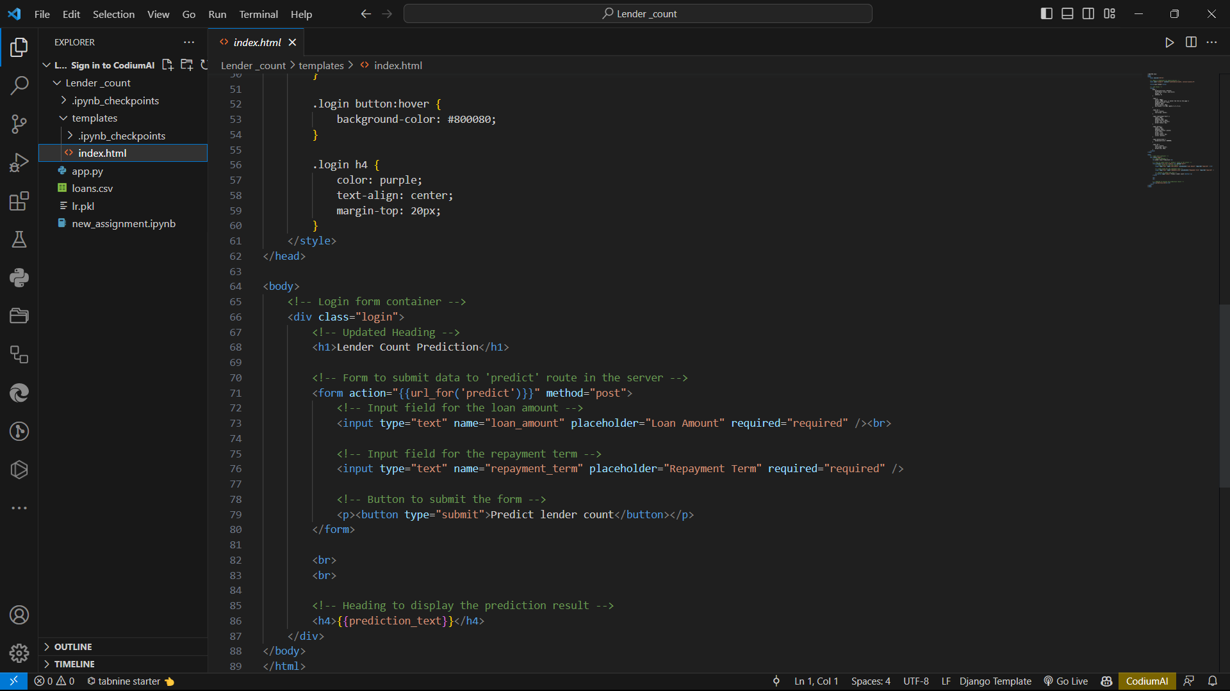

Figure 3.34: Html code

The resulting UI the user interacts with is seen in figure 3.35.

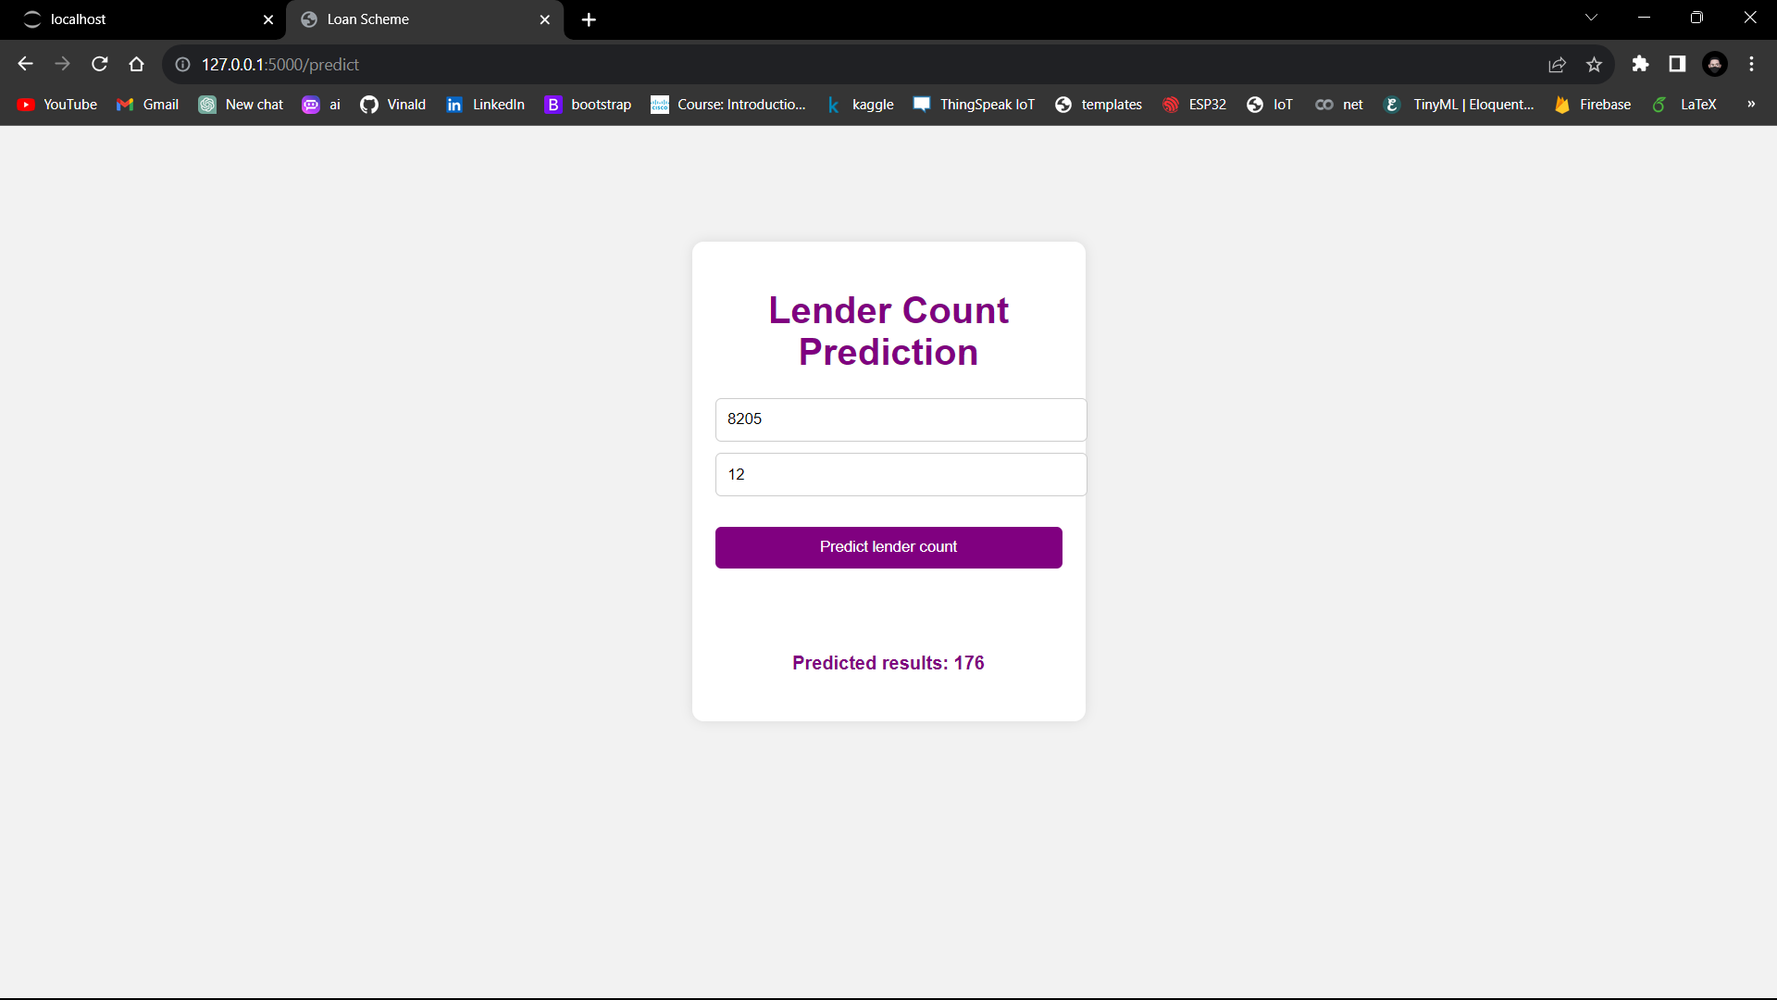

Figure 3.35: User interface

## EMBEDDED SYSTEMS

### Traffic lights System

We worked on traffic light system using the LED, Arduino Uno board, resistors and the jumpers. The code loaded to the board was developed in the Arduino IDE. The prototype was to simulate a real operation traffic light system on one road with four different colors; Red, Green, Yellow and blue as seen in the figure 3.36.

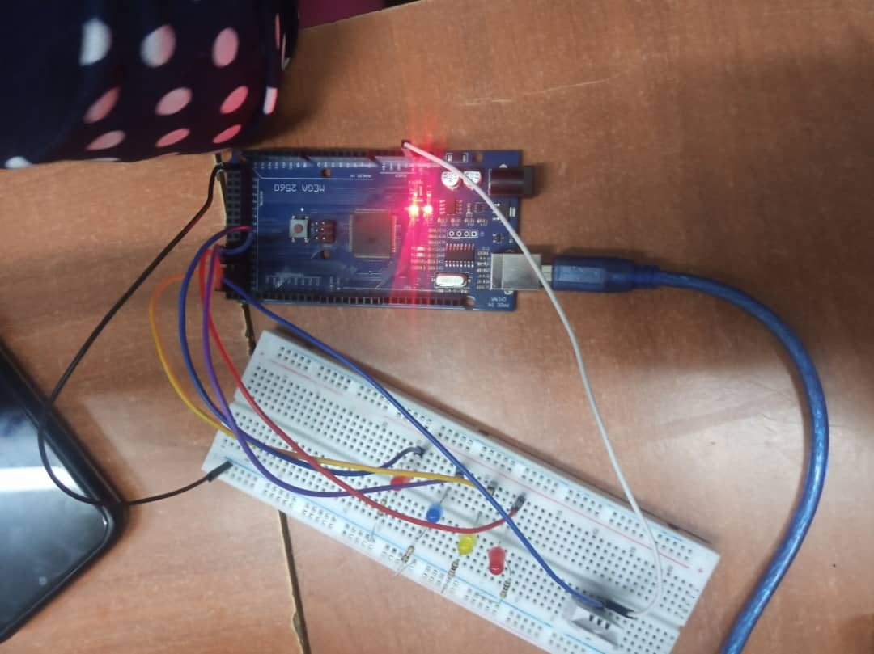

Figure 3.36: Traffic lights system prototype

### Intruder Detection System

Still using the Arduino UNO board we developed an intruder detection system, which used the PIR sensor to detect motion then trigger the Ultrasonic sensor to measure the distance from the object detected. If the distance is less than 100cm, the system turns on the buzzer alarm and also displays the message *“intruder detected at a distance of 40cm”*. The system also had a LED which lights when not intruder detected and blinking when the intruder is within the distance less than 100cm. The figures 3.37 and figure 3.38 show the intruder detection system with figure 3.37 with Arduino code and figure 3.38 the actual setup.

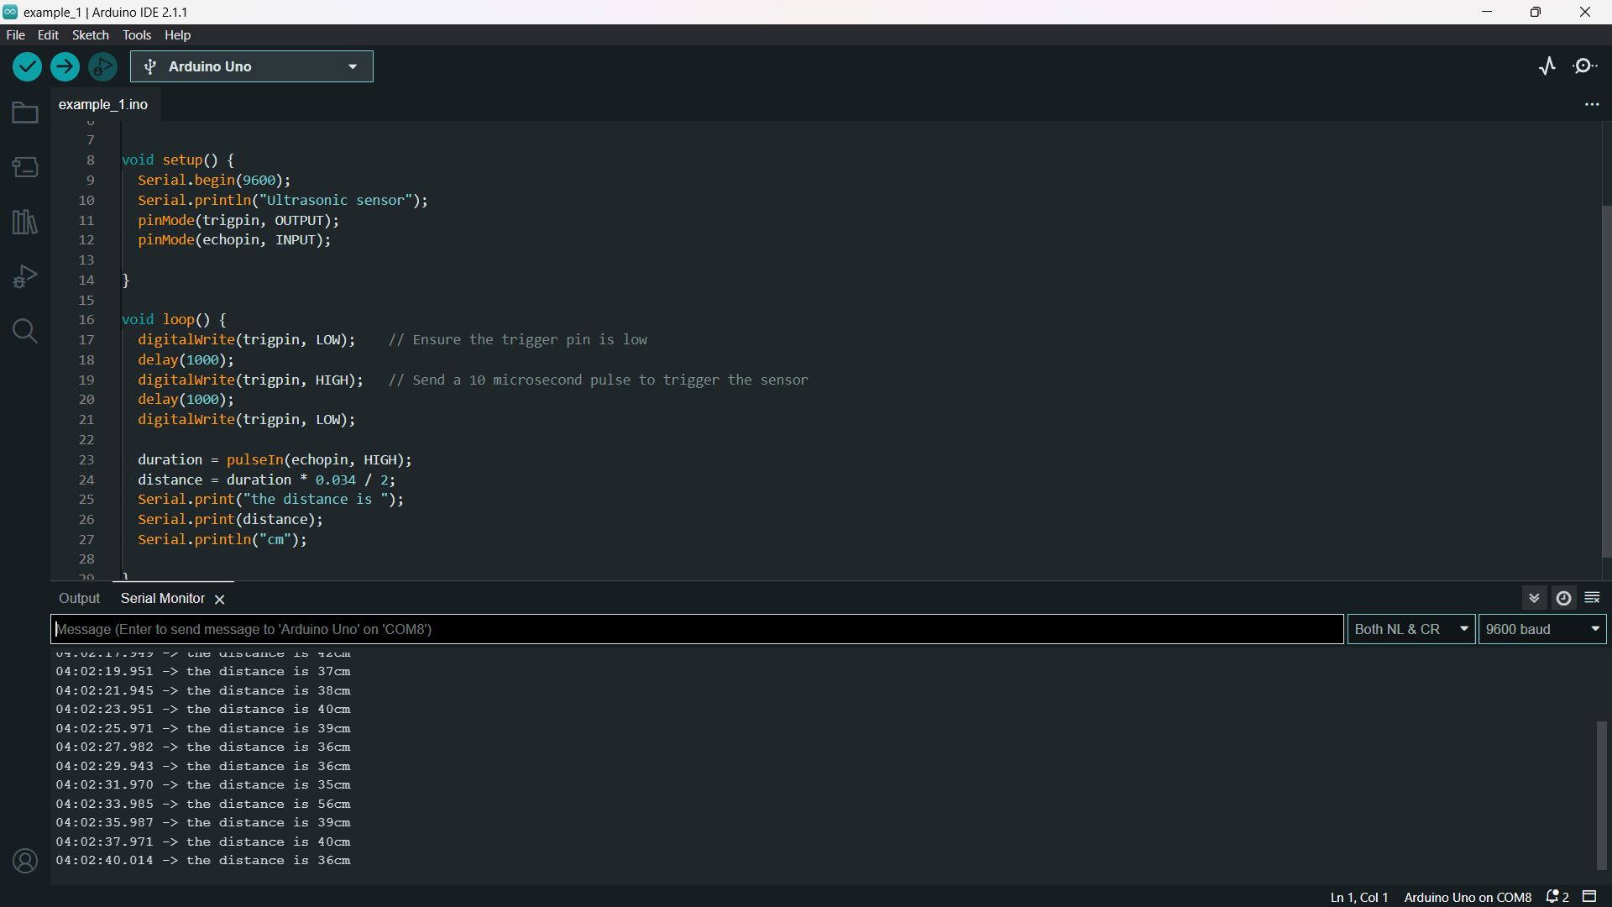

Figure 3.37: Arduino code for the intruder system.

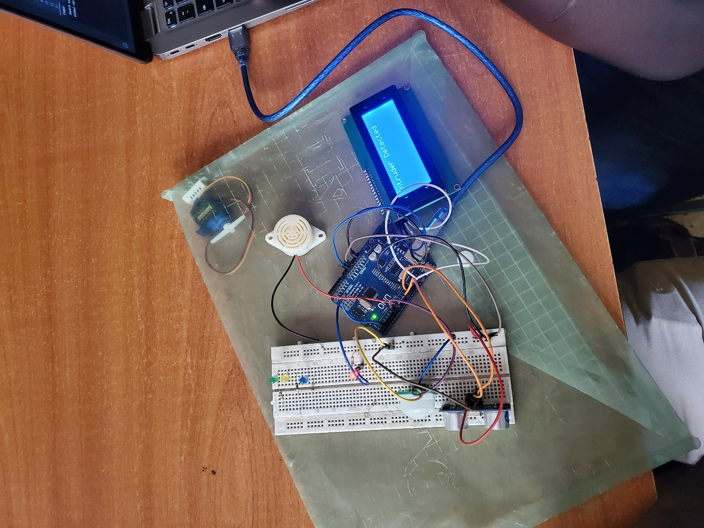

Figure 3.38: Actual setup

### Humidity and Temperature Measuring System

We developed a simple prototype of a system that to read values of the temperature and humidity using the DHT22 sensor and displays the read values to an LCD screen and also send them to serial monitor of an Arduino IDE dashboard. The system was developed using the Arduino UNO, DHT22, jumpers, and code was developed in the Arduino IDE. Figure 3.39 shows the code in the Arduino IDE and figure 3.40 shows the actual physical setup.

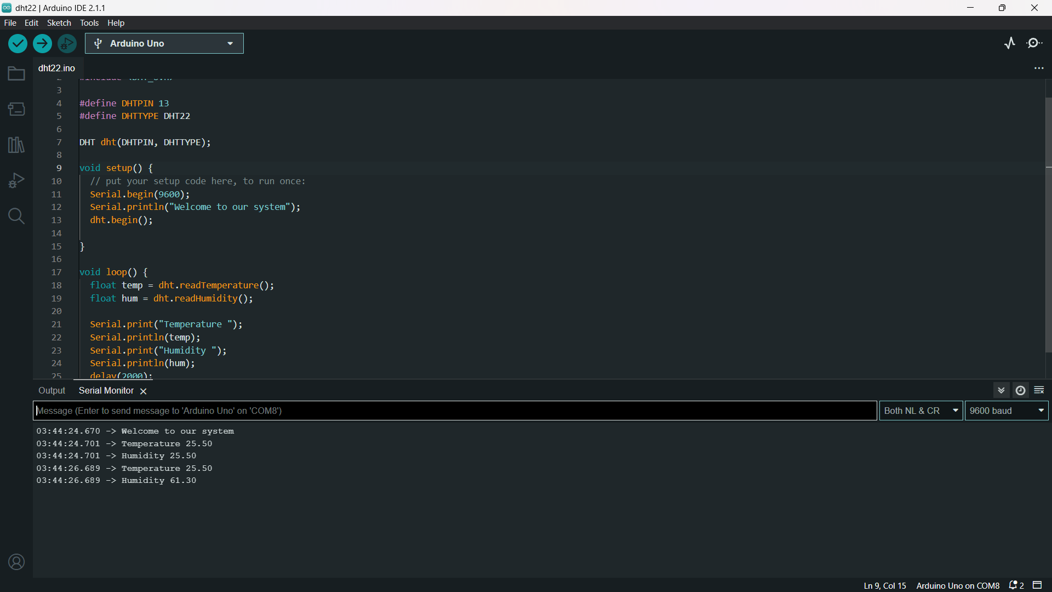

Figure 3.39: DHT code

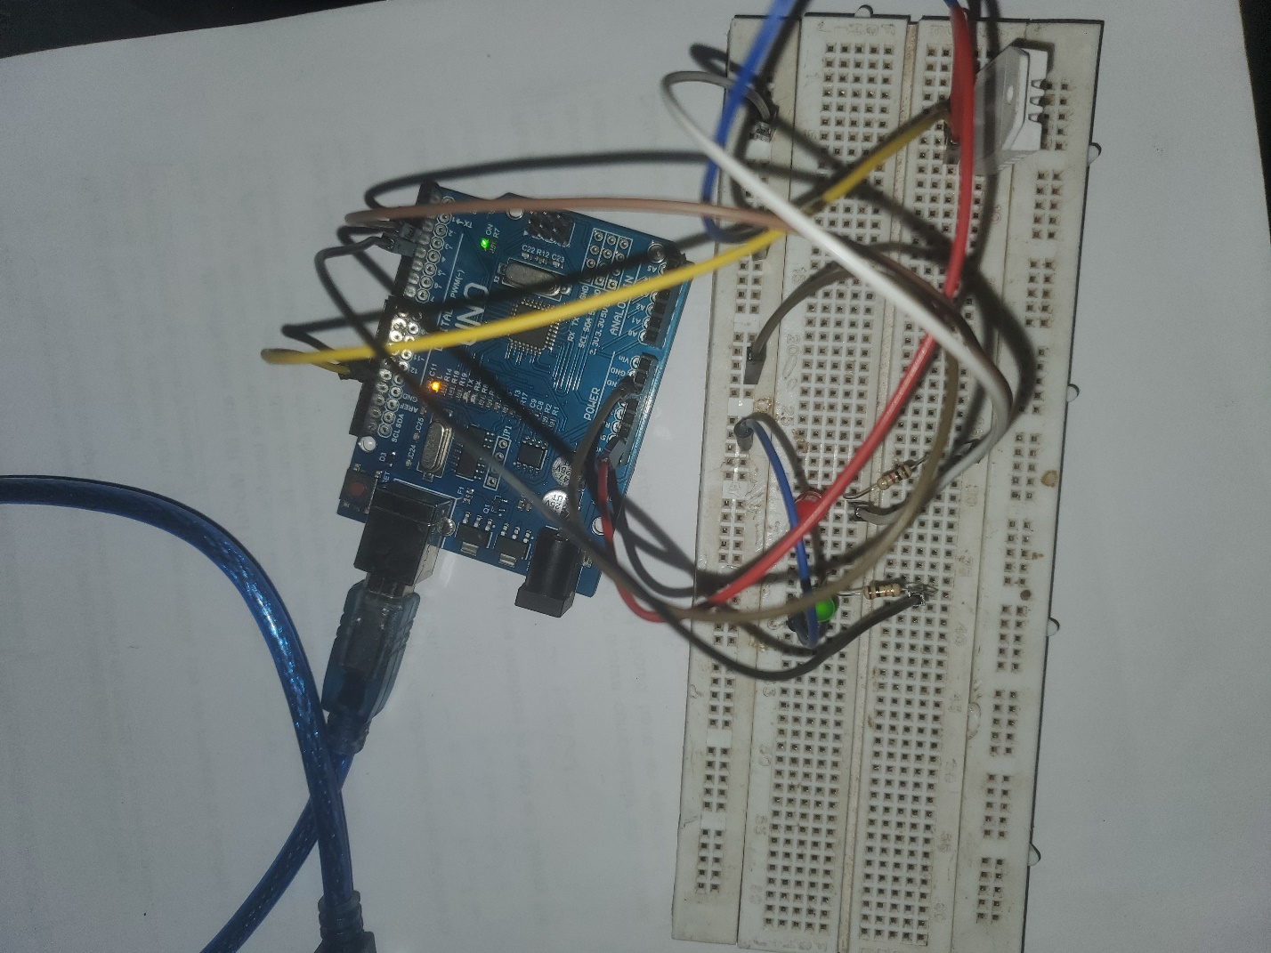

Figure 3.40: DHT actual setup

## INTERNSHIP PROJECT

The project about the smart irrigation system titled “AgriWave Irrigation System” with different component with the main component which was an embedded system on which a machine learning model was deployed and also was responsible for collecting data from the different sensors and also control the actuator.

### Embedded system

This part was concerned with creating an embedded system for the AgriWave project with the main component of ESP32 development board as the heart of the system on which other components were connected to form a complete system as illustrated in the layout digram in figure 3.41.

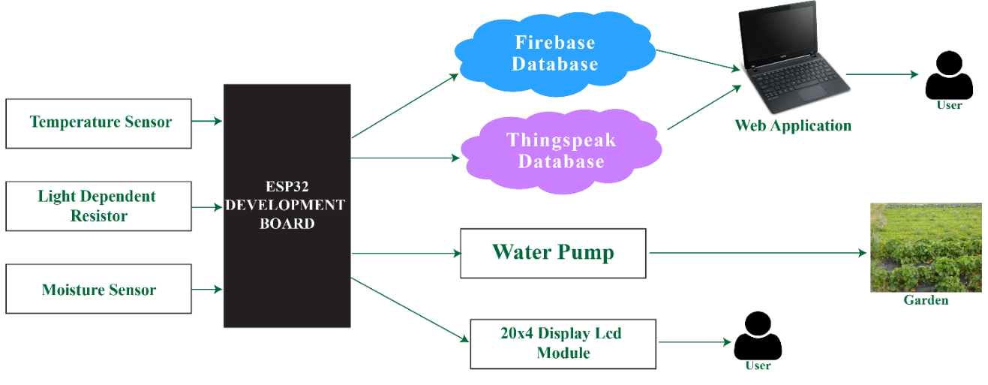

Figure 3.41: Layout of the project system

The different sensors for temperature and moisture plus the light dependent resistor were connected on the ESP32 board to read data from the physical world then the micro-controller uses the read data to make a prediction and also send data to the database and display real time visualizations to a user on the web application of the system.

The system development underwent different prototypes as shown in figure 3.42 of the first prototype and figure 61 the final embedded prototype.

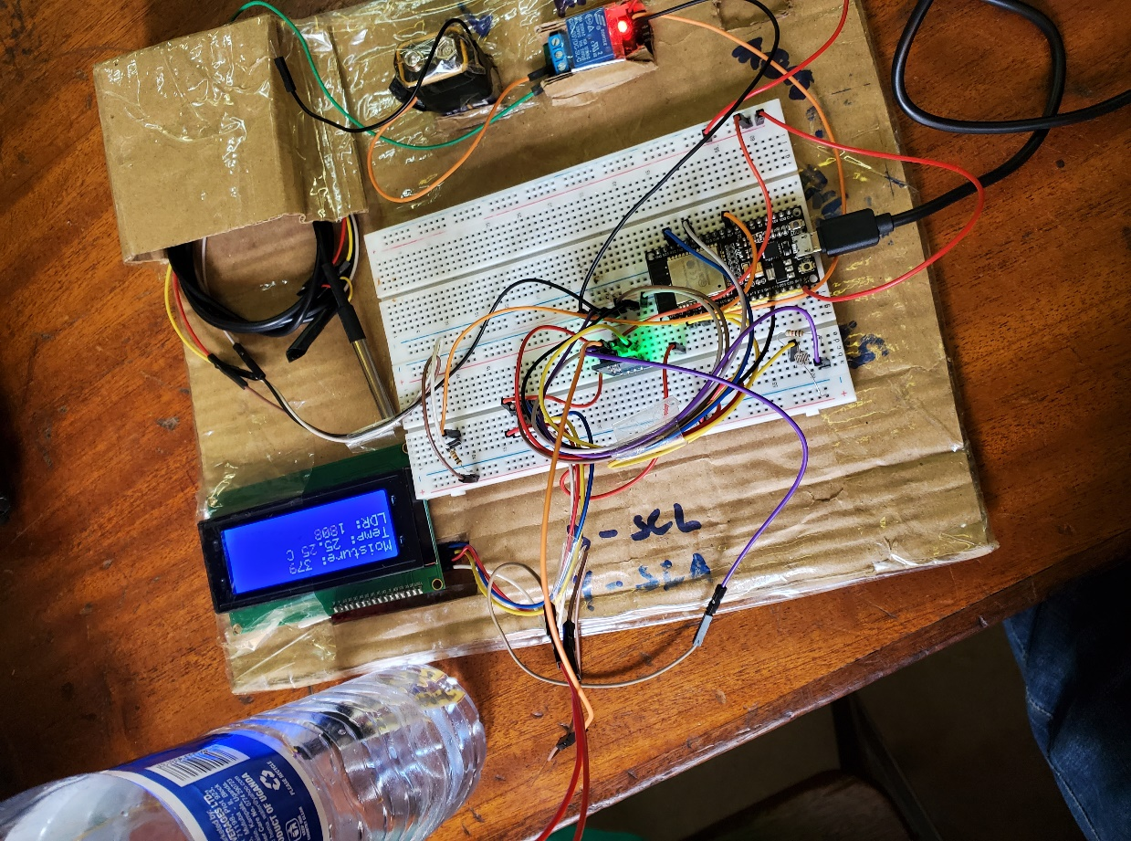

Figure 3.42: Prototype 1

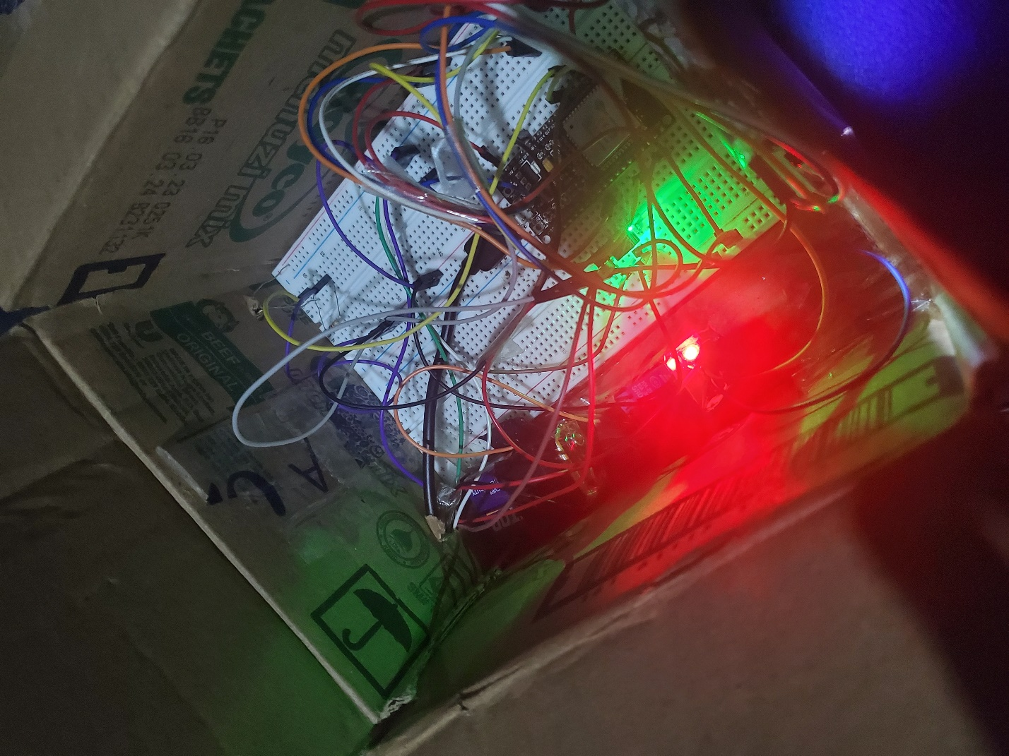

Figure 3.43: Final prototype

The code run on the ESP32 was developed in the Arduino IDE and a sample of the code is shown in figure 3.44, figure 3.45, figure 3.46 and figure 3.47.

|  |  |
| --- | --- |
| Figure 3.44: General variables | Figure 3.45: Setup Loop |

|  |  |
| --- | --- |
| C:\Users\okiro\Pictures\Screenshots\Screenshot (69).png  Figure 3.46: Void Loop | Figure 3.47: Functions |

### Machine Learning

By recognizing patterns in your data and then making predictions based on these frequently complicated results, machine learning tries to answer business questions, discover and analyze trends, and assist in issue resolution. Our research question was to anticipate whether or not irrigation was required. These forecasts were designed to provide instructions to the embedded system's pump. The provided data set was used to design and build a model for automatic irrigation prediction on the ESP32 board, as well as a web application for manual irrigation prediction. After that, the model was saved as a joblib file and translated to a.cpp file that could be run on the ESP32.

Exploratory Data Analysis was designed to assist us in better understanding our data by removing constraints in the data, determining which attributes are most relevant, and determining how to best answer our research question as shown in figures 3.48, 3.49, 3.50, 3.51, 3.52, 3.53.

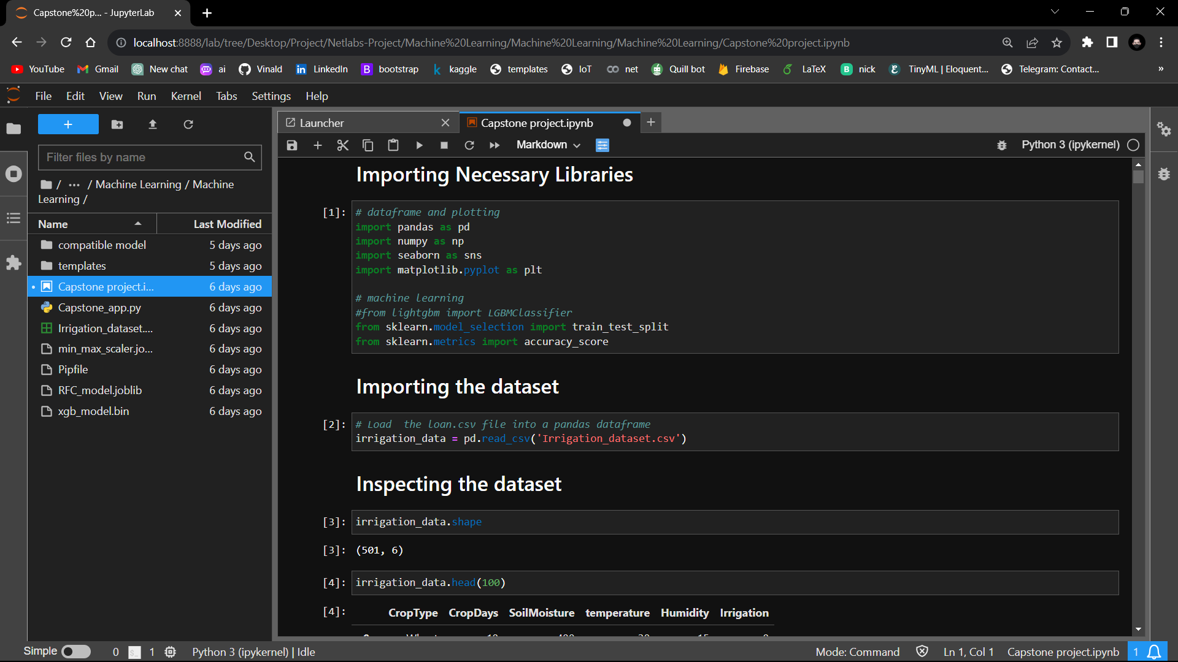

Figure 3.48: creating a data frame

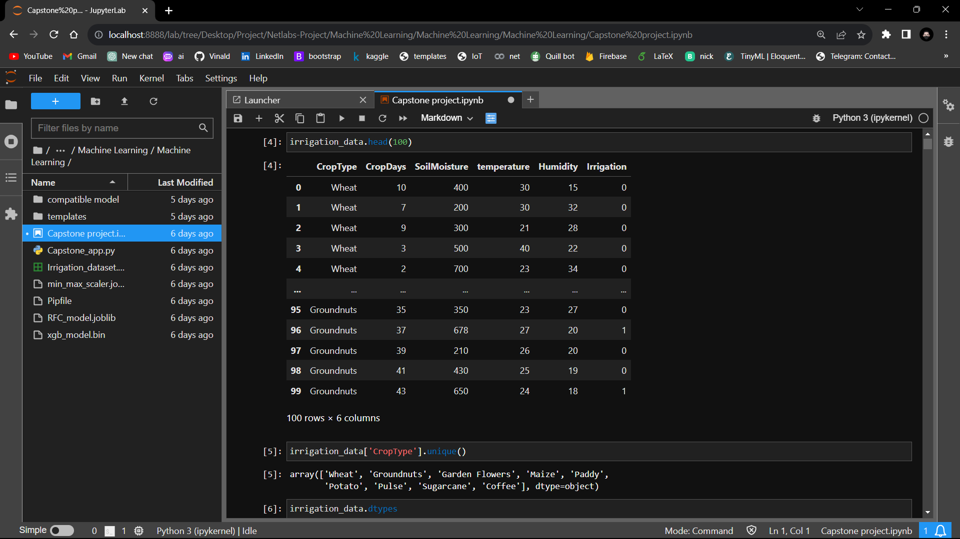

Figure 3.49: Features in the data set

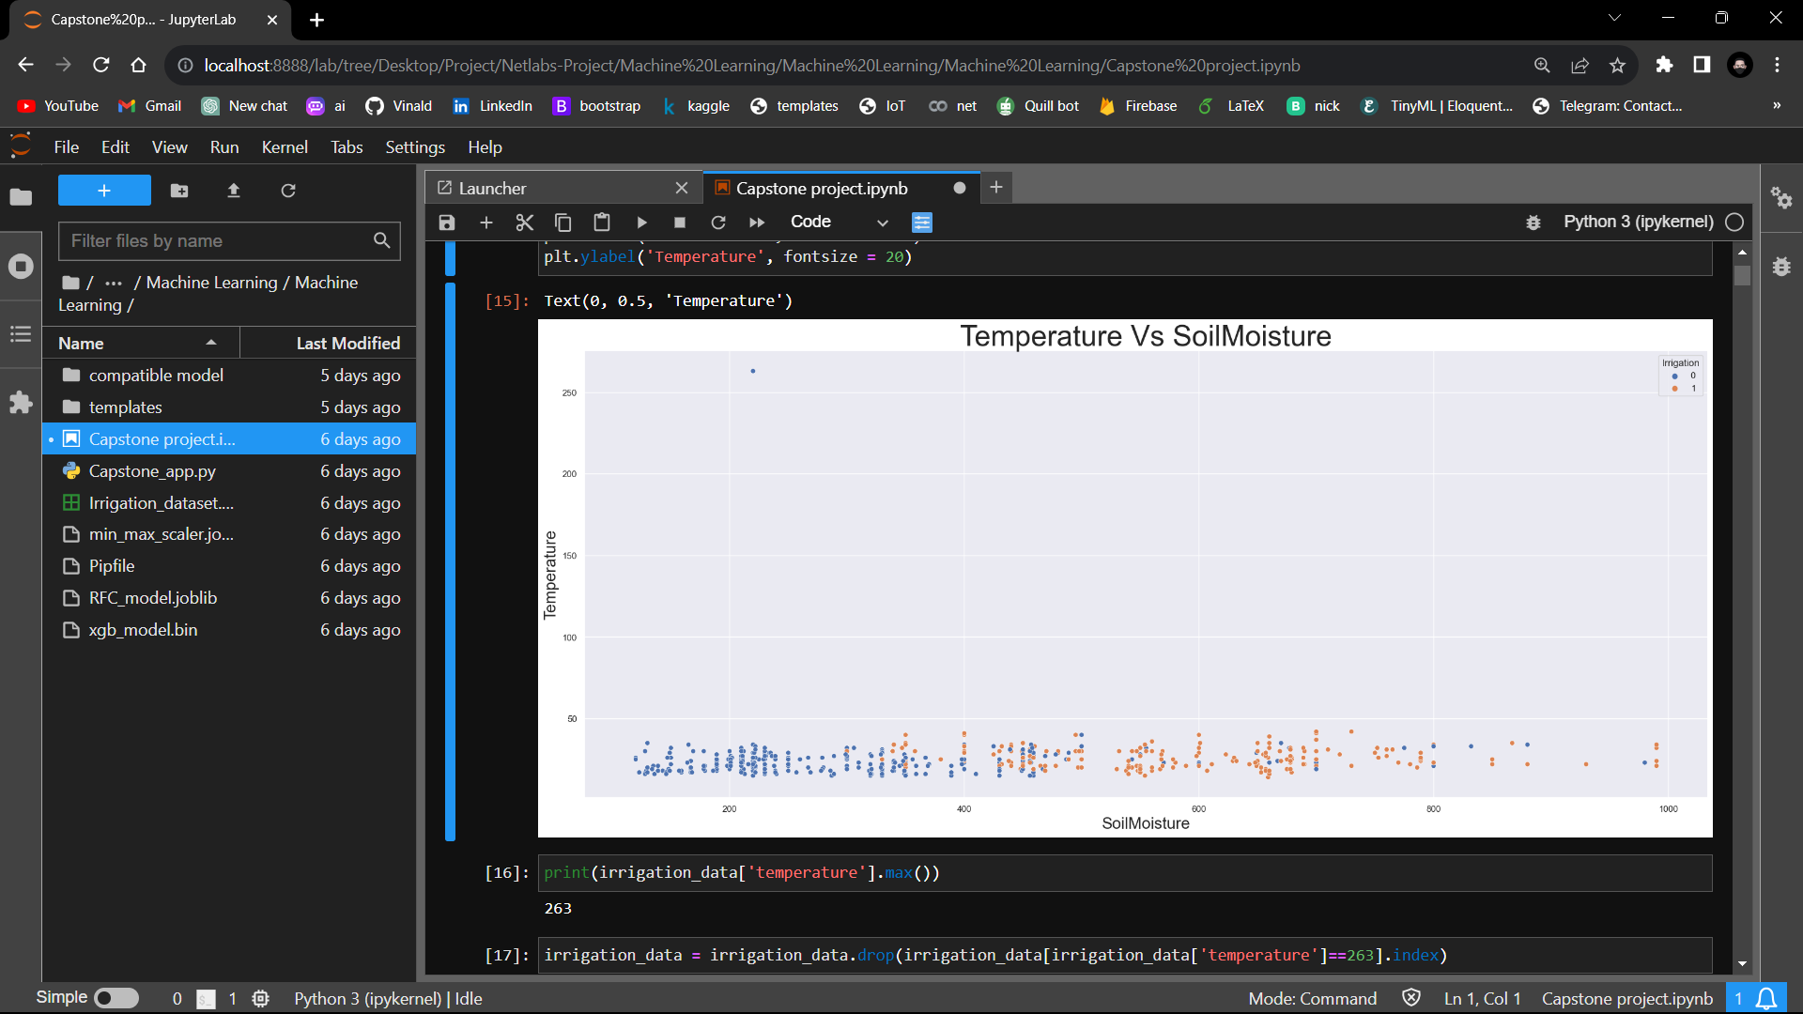

Figure 3.50: Temperature Vs Soil moisture

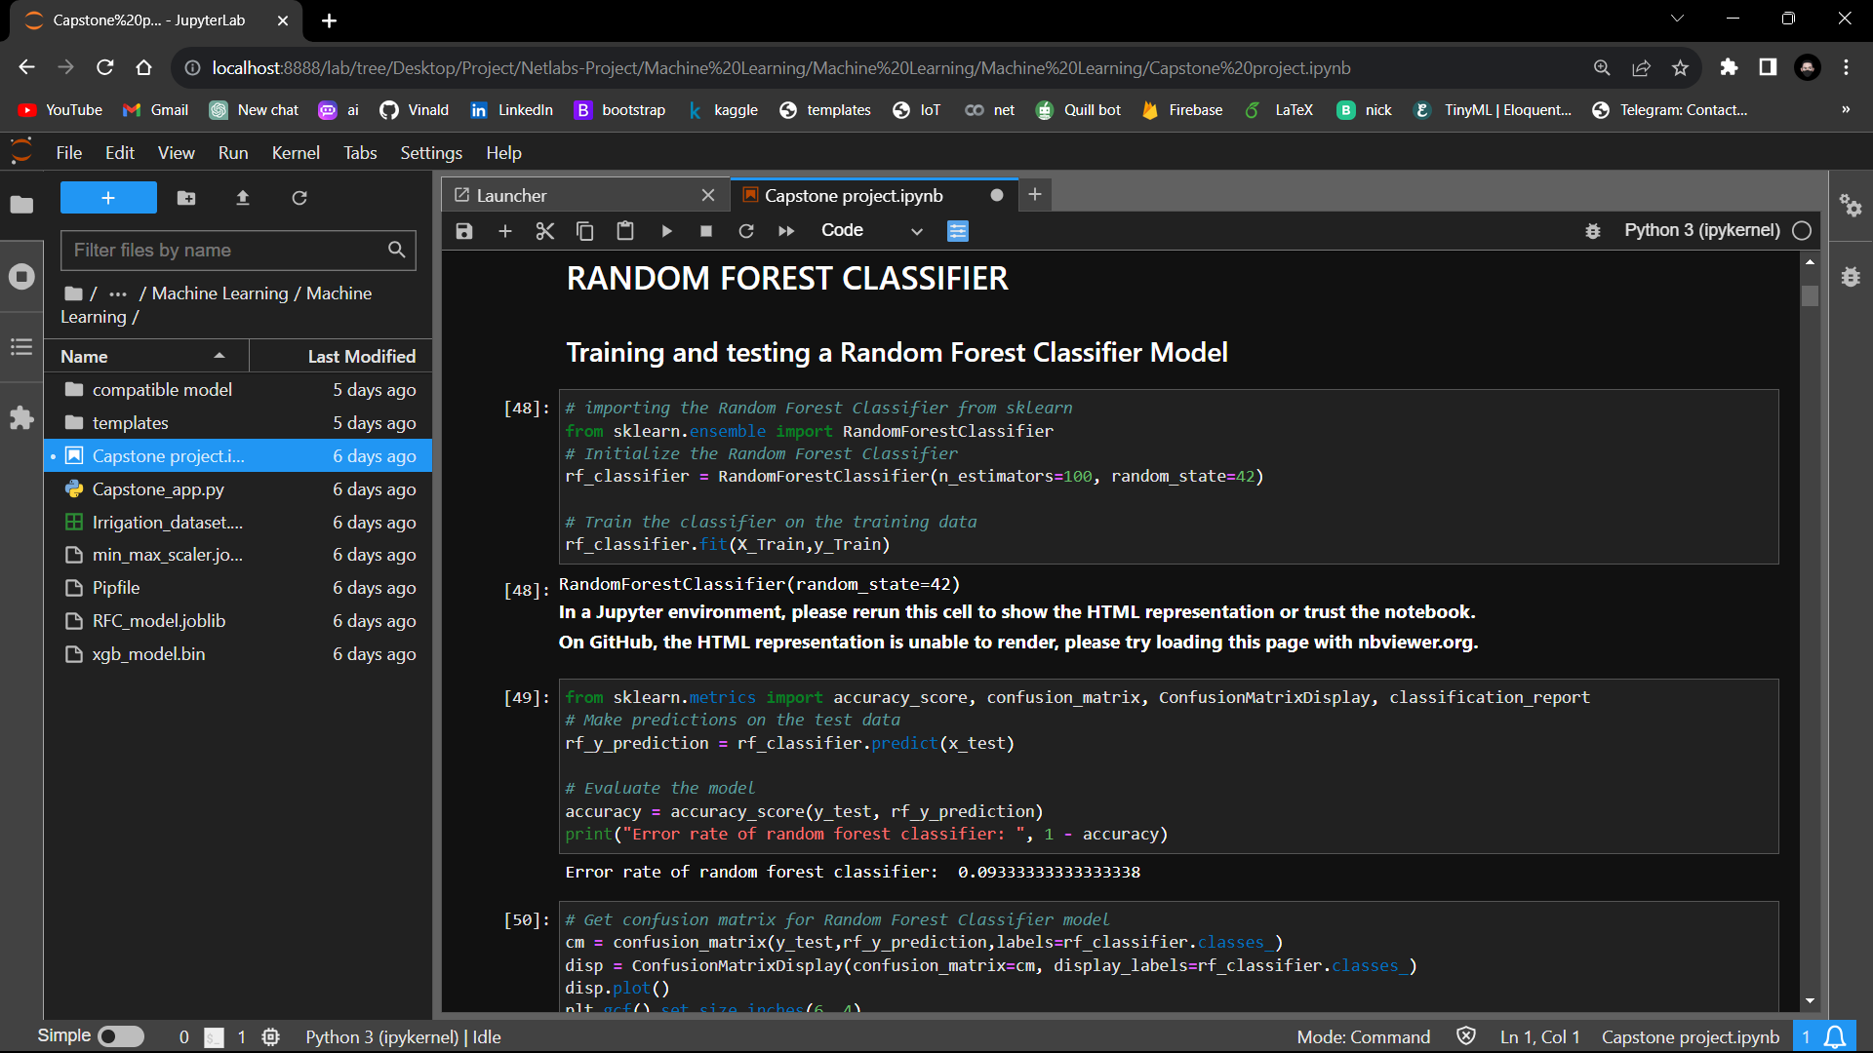

Figure 3.51: Making a ML model

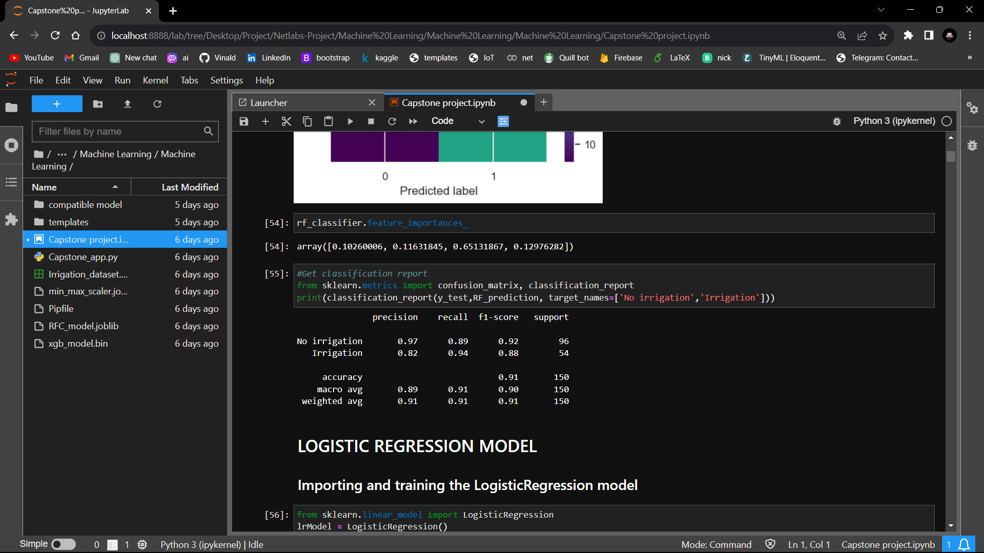

Figure 3.52: Evaluation of the model



Figure 3.53: Saving joblib file

### Web application

The web application was designed using the python frame work flask for the back-end as shown in figure 3.54 and front-end with Html, CSS, and Java script as shown in figure 3.55.

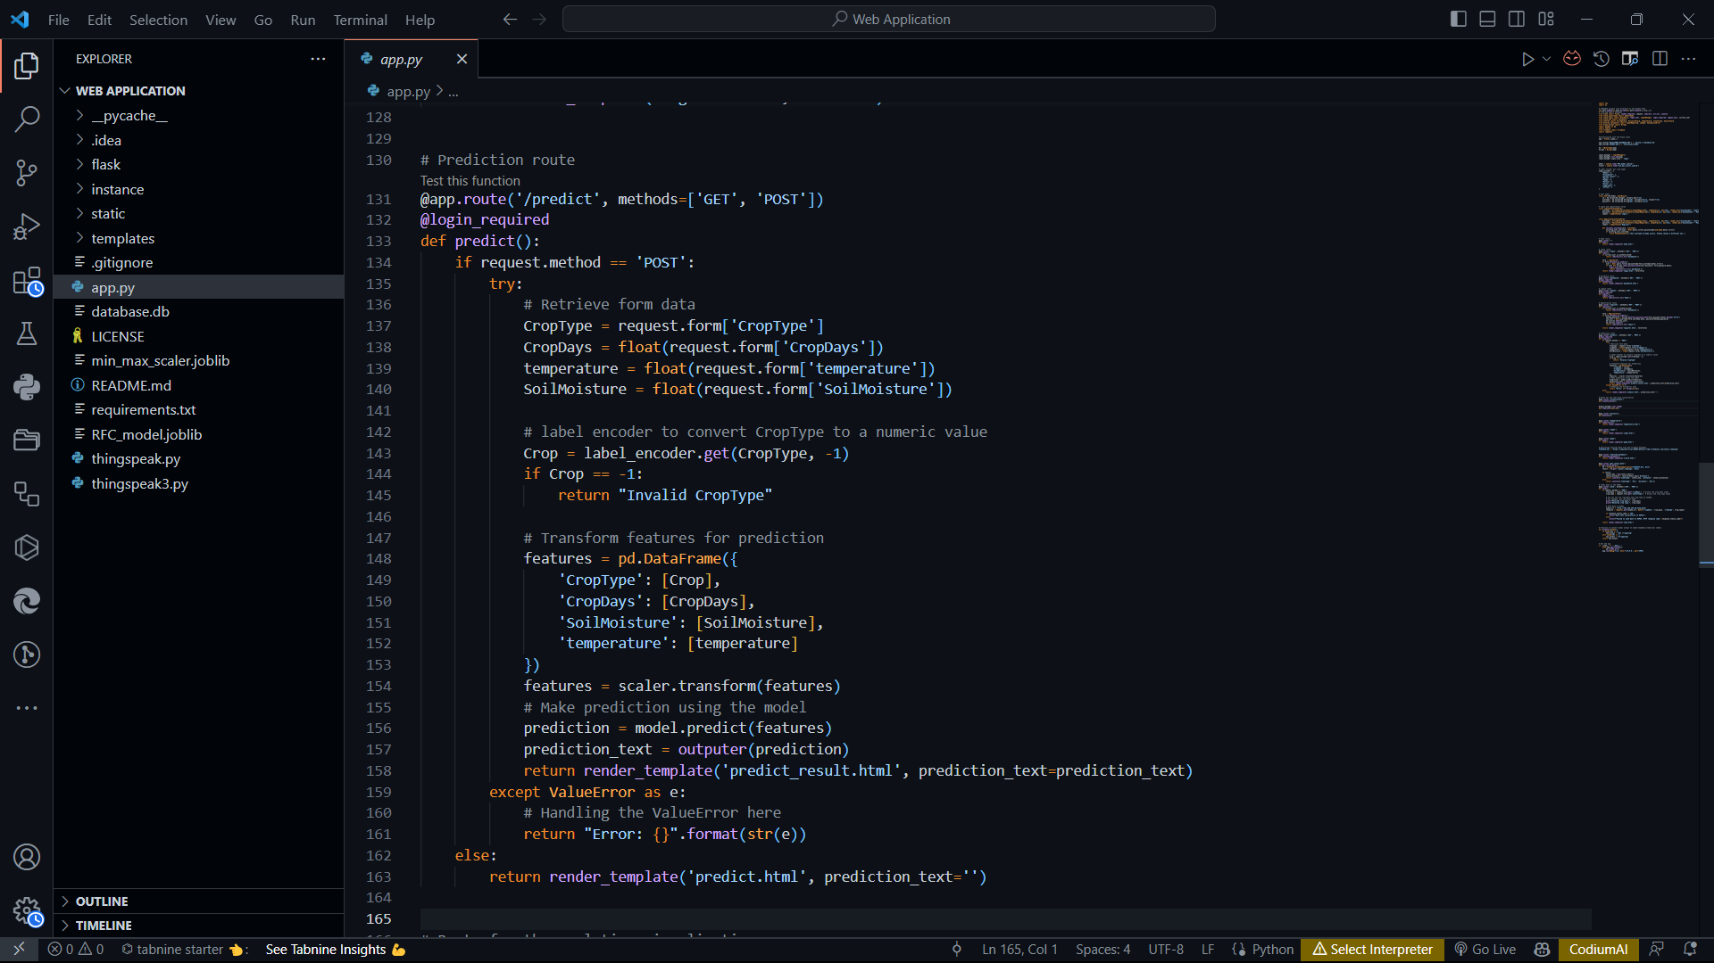

Figure 3.54: Flask Code for the System

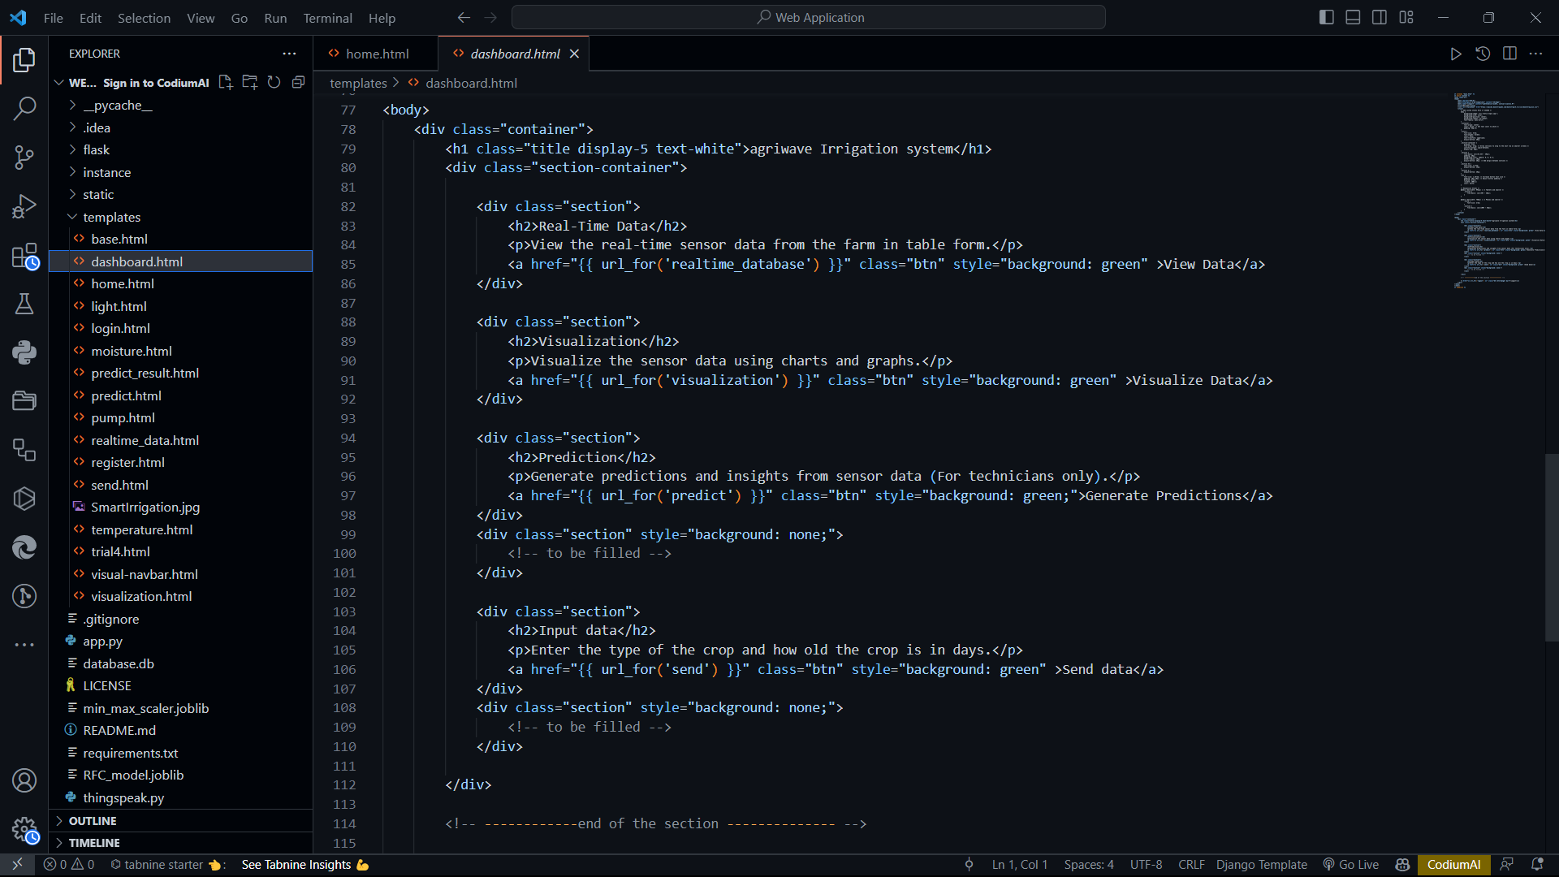

Figure 3.55: Html code

The web application launches with a welcome screen as shown in figure 3.56 that requires a user to either login or register in order to access the system application.

|  |  |
| --- | --- |
| Figure 3.56: Welcome Page | |
| Screenshot (61)  Figure 3.57: Register page | Screenshot (60)  Figure 3.58: Login Page |

Once a user logins in successfully they are presented to the dashboard as shown in figure 3.59 that has different menu items for a user to choose from which include real time visualization, database, and manual prediction and send data to the ESP32.

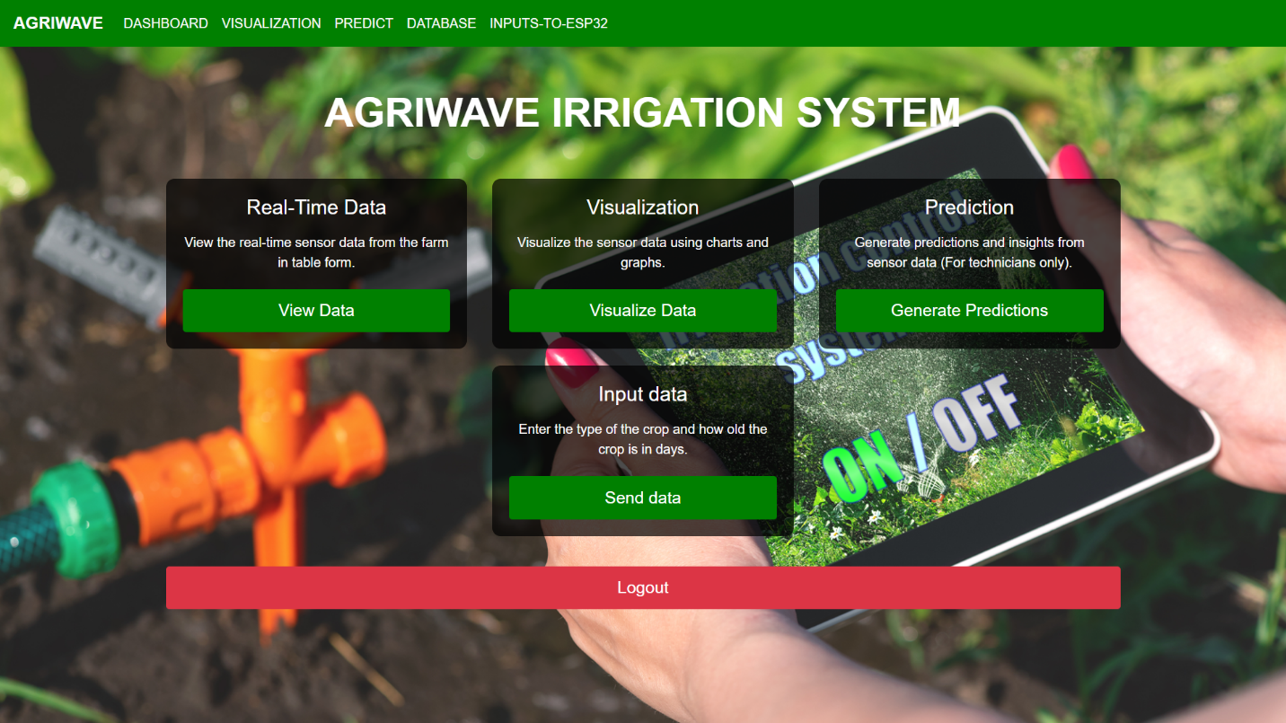

Figure 3.59: Dashboard

The application displayed the visualization using graphs and widgets as shown in the figure 3.60.

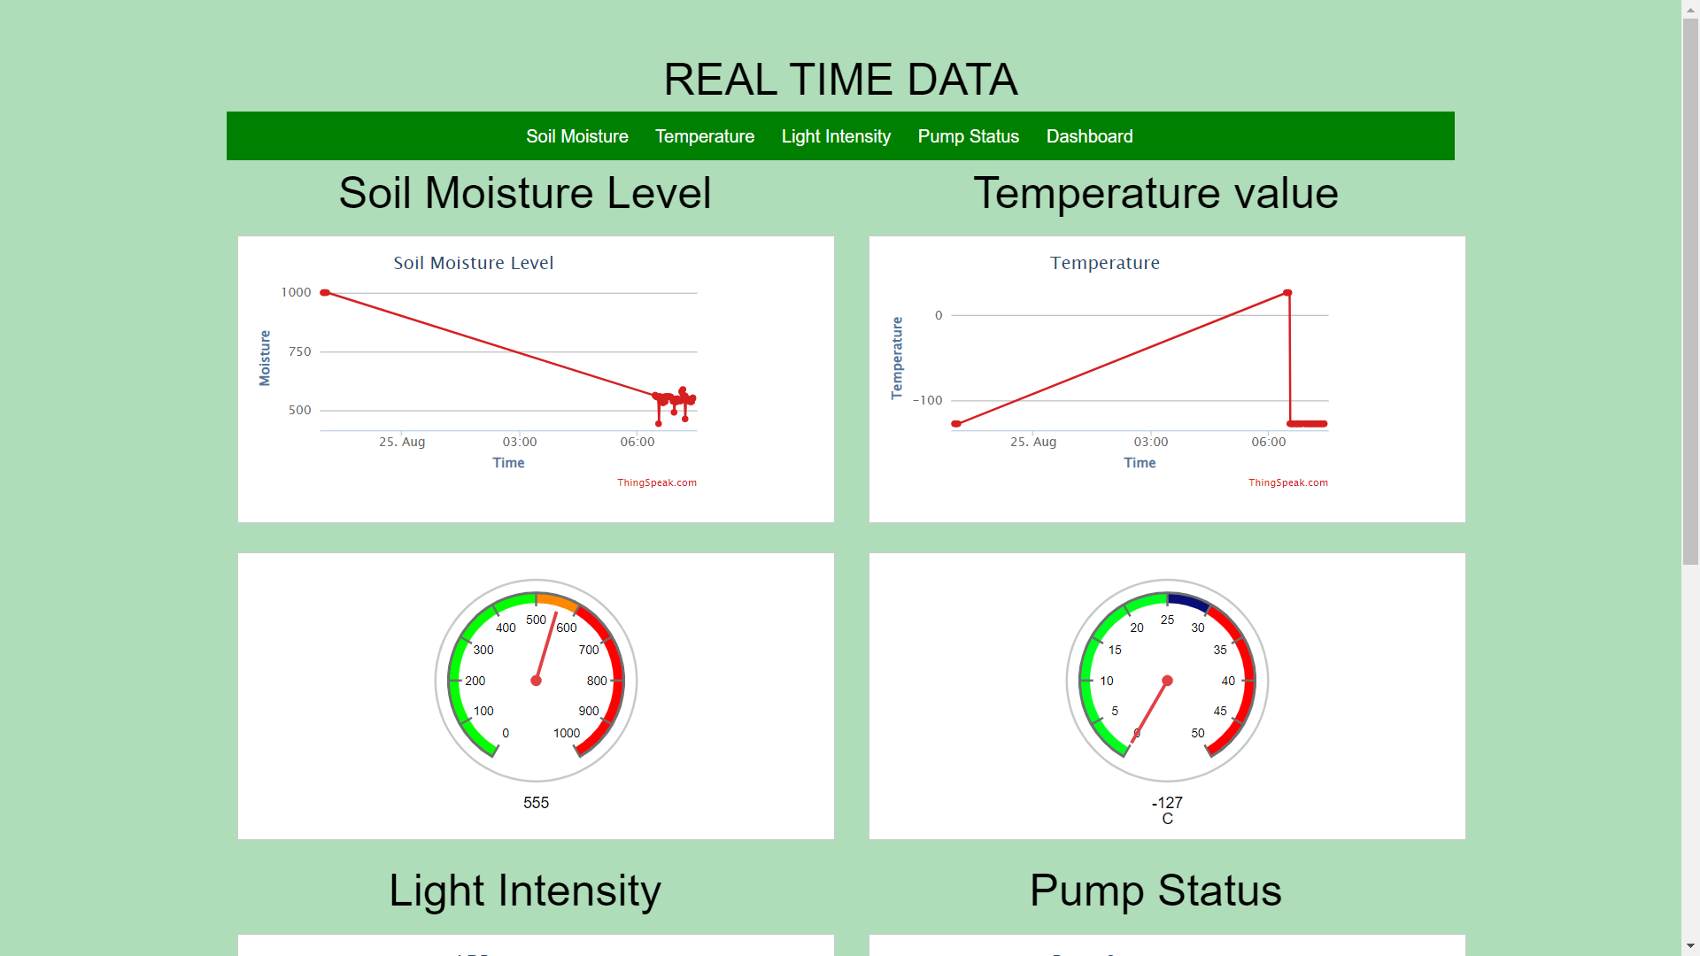

Figure 3.60: Real time visualization

The authorized user of the system could send the crop type and the how old the crop was to the ESP32 to alter with the seasons and this made the system to be used at any farm and at anytime as seen in figure 3.61.

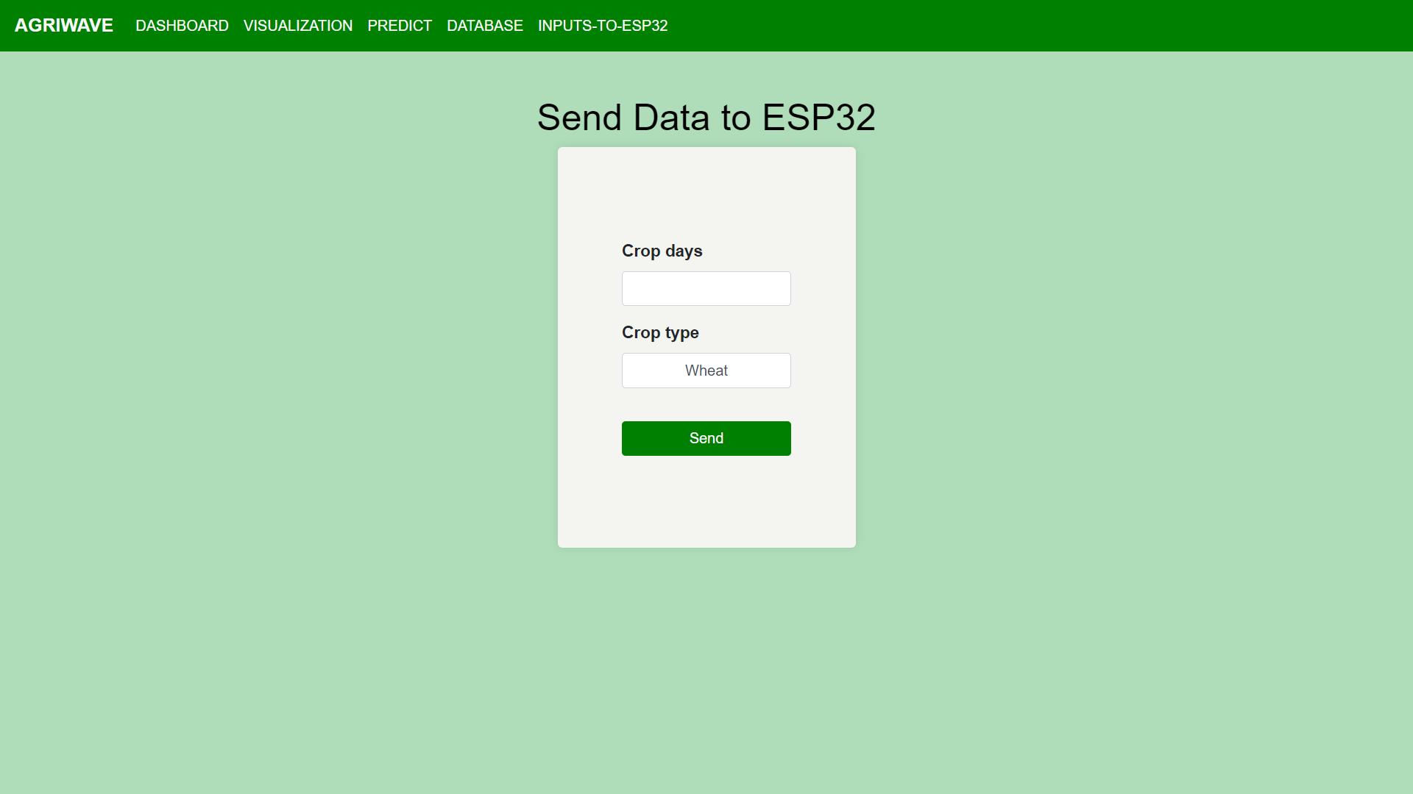

Figure 3.61: Send data to ESP32

The application was designed to be responsive to different screen sizes using the bootstrap framework. With all the three parts integrated a fully operating irrigation prediction system was created and a presentation to the staff of netLabs!UG was made we concluded the internship.

# CHAPTER FOUR ACHIEVEMENTS, SUMMARY, CHALLENGES, RECOMMENDATIONS AND CONCLUSION

## INTRODUCTION

This chapter contains the skills and experience gained by the internee, the challenges faced, and summary of the whole report, the achievements made, the recommendations and the conclusion of the report.

## ACHIEVEMENTS AND SKILLS GAINED

Throughout the period of internship training, the internee accumulated a lot of knowledge and skills. The skills gained include; python programming both basics and advanced python programming, machine learning especially supervised machine, web development using flask, embedded systems, installation of different application on different operating systems, project planning and supervising of different projects, communication and management skills through different projects, and problem solving skills. The internee also gained experience in working with team members on the same projects, observation of the code of conduct, work ethics and the chain of command at the work place.

## CHALLENGES

There was little time allocated to training the new concepts and essential modules which an internee needed to successfully execute all the projects assigned to him for example Machine learning concept.

The equipment and resources like the Arduino development boards for carrying out practical work at netLabs!UG were limited this hindered faster training and to fully engage in practically since the internees practiced only when they were together at the work place

The practical sessions were highly affected by power blackouts that were rampant during the training period due to rainy season.

## RECOMMENDATIONS

### Recommendations to Future Internees

As an internee, I recommend future internees to be assertive in seeking internship placements, to ask as many questions as they can, to network and try to meet as many people as they can, to be open minded and always ready to learn, to be proactive and utilize the opportunities that present themselves over the course of internship, to have mentors in line with their career choices, to do as much research as they can concerning the activities that are relevant to their program and can provide future employment, to be themselves and avoid pretense as well as being ethical and responsible in all they do.

Also get into the habit of documenting whatever task you do on a daily basis. The records made are not only important and useful when writing your final report, but also very important as a reference in future when faced with similar tasks and finally a good supervisory relationship is pivotal to successful completion of your degree.

### Recommendations to the organization

The internee recommends the organization to give internship placements to as many students as they can, to engage the students in company activities especially projects, to encourage students to volunteer with the organization. The organization should give deadline based tasks focusing more on delivering outputs showcasing competences in advanced Technologies, would be a better time saving strategy. I highly recommend that internees do more of the practical work most especially in hardware and networking at netLabs!UG.

### Recommendations to the university

I recommend the university to brief students about the relevant internship activities that can guide them towards career opportunities of their passion. The university should create a platform for students to practice and continue the activities learnt during internship through workshops. This will encourage students to practice the information they are taught instead of trashing it. Also, the university should consider pushing internship to the final year as well to increase the chances of the internees being retained by potential employers after graduation.

## SUMMARY

The report begins with a brief introduction about the content of the report followed by the student experience and finally internship evaluation. The internee has discussed the learning objectives with which he undertook the program followed by the learning outcomes wherein he understood the python programming, machine learning, web development, different communication, and leadership skills that was essential to handle different kinds of situations in the organization during my internship program in an effective manner.

Makerere University sends out students for field attachment with the main objective of enabling the students to get hands on real life experiences in environments they are expected to work in when they graduate. netLabs!UG was well prepared to take on the student for field attachment in the position of a Post graduate researcher.

The internee was exposed to new Technologies in the learning, including Anaconda Navigator, Flask framework, bootstrap, JavaScript. He used these Technologies to work on projects such as the student record management system, final internship project.

**Strengths:** Strengths are factors that provide people with competitive advantage. The internee possessed a high level of computer skills, and knowledge about most computer related tasks. The field attachment helped the student to apply the knowledge taught at university to the field of work by working on real life projects. The field supervisors were very helpful and offered great guidance. This helped the student to learn a lot of new knowledge and skills as indicated throughout this report.

**Weaknesses:** The internee had little awareness about office etiquette and generally the limited knowledge about the working world and he was unable to have longer physical interactions with the tutors during internship due to the limited time for internship. On the side of the university, there was a weakness of late academic supervisor allocation that in turn delayed the supervision schedules. The internship period was quite small, cutting short the great experiences at their climax.

## CONCLUSION

During internship training the internee noted that organizations set strategic goals and objectives which they strive to achieve thought their day to day operations. Unless these strategic goals are attained, the organizations can never move towards achieving the desired competitive advantage.

Application of ethical code of conduct helps organizations and management to realize their responsibilities to the different stakeholders such as the society, employees, customers which in turn facilitate business growth due to the long-term relationships built. Employees and managers act as the organizational ambassadors’ there for the way they act and behave depicts the organizations’ image thus a need to portray ethical behavior.

Internship is a good opportunity for the internee to mature while interfacing with potential areas of future employment and apply the theoretical knowledge taught to solve everyday problems in their area of expertise. The intern gained knowledge, skills and met many new people and the two most important things he has learnt are time management and self-motivation. Finally, I extend my sincere gratitude to netLabs!UG staff for the support they gave us.

# REFERENCES

|  |  |
| --- | --- |
| [1] | "Makerere University Policies," Makerere University, [Online]. Available: https://cedat.mak.ac.ug. [Accessed 11 08 2023]. |
| [2] | "Courses," Makerere University, [Online]. Available: edat.mak.ac.ug/schools. [Accessed 11 08 2023]. |
| [3] | Ó. Diarmuid, "documentum," netLabs!UG, [Online]. Available: www.netlabsug.org/documentum/netLabs!UG-Launch.pdf. [Accessed 13 08 2023]. |
| [4] | netLabs!UG, "About Us," netLabs!UG, [Online]. Available: http://www.netlabsug.org/. [Accessed 13 08 2023]. |
| [5] | D.O'Briain, "Python Programming,," [Online]. Available: http://www.obriain.com/training/python3/20190608-Python3-Course\_odt\_v2.5.pdf. [Accessed 15 08 2023]. |
| [6] | W. McKinney, "Data loading, storage and file formats," in *Python For Data Analysis*, 2013, pp. page 155-176. |
| [7] | M. Banoula, "ML steps, a complete guide," [Online]. Available: https://www.simplilearn.com/tutorials/machine-learning-tutorial/machine-learning-steps. [Accessed 20 08 2023]. |
| [8] | I. T, "Externally validated model predicting," [Online]. Available: https://pubmed.ncbi.nlm.nih.gov/33812010/. [Accessed 01 09 2023]. |
| [9] | S.Robert, "What is a sensor?," [Online]. Available: https://www.techtarget.com/whatis/definition/sensor. [Accessed 08 2023]. |
| [10] | "DHT11, DHT22 and AM2302 Sensors," [Online]. Available: https://learn.adafruit.com/dht/. |
| [11] | "Arduino-Ultrasonic Sensor," [Online]. Available: https://www.tutorialspoint.com/arduino/arduino\_blinking\_led.htm. |
| [12] | M. Rafiquue, "Journal of Physics: Conference Series Design and Development of Smart Irrigation and Water Management System for Conventional family," [Online]. Available: https://iopscience.iop.org/article/10.1088/1742-6596/1844/1/012009/pdf. [Accessed 23 08 2023]. |

# APPENDIX 1: ACCEPTANCE LETTER



# APPENDIX 2: CERTIFICATE

